1. 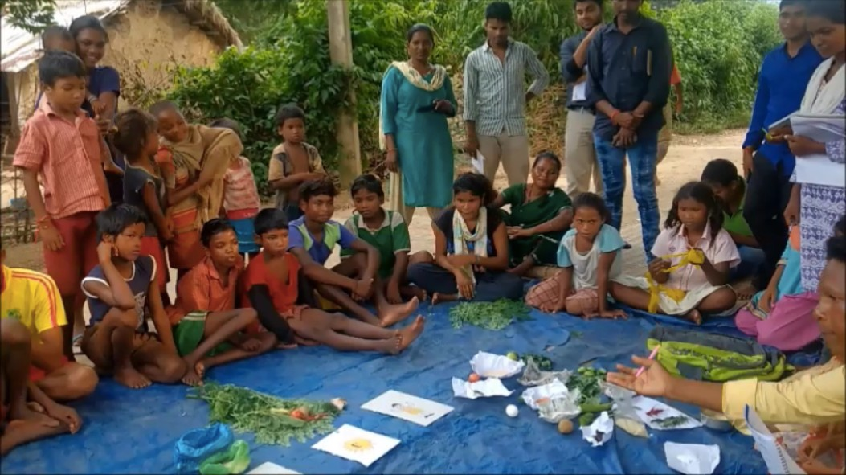

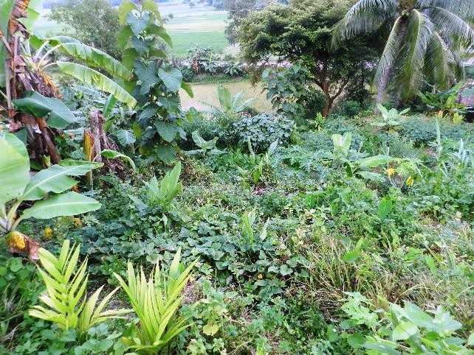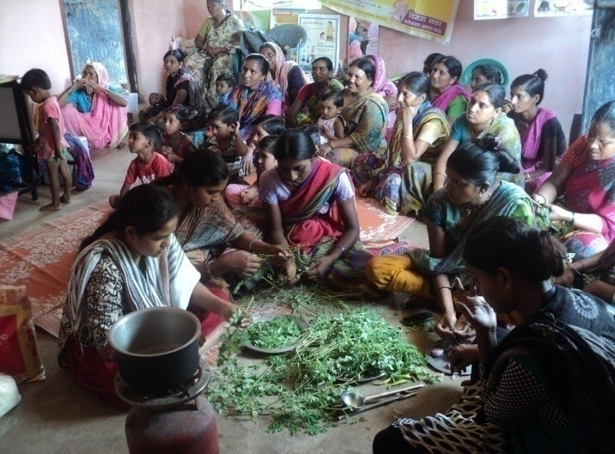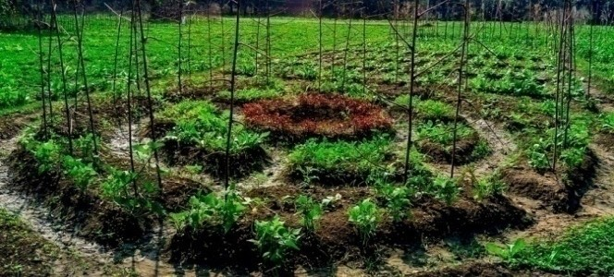

**Compendium of Nutri-Garden interventions in India**

**We wish to thank all those who worked together to create this knowledge compendium on nutri-garden interventions in India including all featured organizations, CFNS and CTARA team members who are responsible for conceptualizing, collating information, designing and preparation of the document without which this would not have been possible. Rigorous efforts have been made to include as many organizations as much as possible in a considerate time frame.**

**This is a sincere effort of compilation of nutri-garden interventions through the information provided by the respective organizations.**

**COMPENDIUM OF NUTRI-GARDEN INTERVENTIONS IN INDIA**

**The Coalition for Food and Nutrition**

**Security (CFNS)**

**January 2021**

**Editorial**

**Prepared by:**

Ms. Anchal Purbey (Strategic Engagement & Communication Manager, CFNS)

Mr. Utpal Chetia (State Program Head-Assam, CFNS)

**Instruction manual developed and supported by:**

Mr. Dnyaneshwar Sanap (Post Graduate student-CTARA, IIT Bombay)

**Conceptualized by:**

Prof Satish B Agnihotri (Emeritus Fellow, CTARA, IIT Bombay & Board Member, CFNS)

**Information provided by- representatives of organizations:**

Ms. Anu Anmol (HZL-Vedanta) | Mr. Arvind Kumar (CORD)| Dr. Bhavani R V (MSSRF)| Dr. Chandrashekhar Biradar (ICARDA-CGIAR) | Dr. Ishaprasad Bhagwat (Tata Trust) | Ms. Meera Mishra (IFAD)| Ms. Neha Khara (GIZ)| Dr. Nirmala Nair (Ekjut)| Mr. Palash B Chatterjee (Semina Agro) | Mr. Parimal Chandra (Swabhimaan-UNICEF) | Dr. Pawan Kumar Patil (Action Against Hunger) | Dr. Rajashree Joshi (BAIF)| Mr. Rajib Kumar Roul (APPI)|Mrs. Suhita Chakraborty (NRLM) | Ms. Sweta Banerjee (WHH)|

**Acknowledgement**

Compendium of Nutri-garden interventions in India has been possible due to the contributions of various organisations who have shared their best practises and supported with additional information’s. Two webinars held around nutri-garden in the month of August and September 2020 and the subsequent momentum and interest generated have encouraged us to come out with this compendium of best practises. We thank all those who have supported these webinars - Mr Anshuman Das (WHH), Dr Avula Laxmaiah (ICMR-NIN), Dr Bhavani R V (MSSRF), Mr. Binu Cherian (Harvest Plus), Dr Chandrashekhar Biradar (ICARDA-CGIAR), Dr Devika Gali (Piramal Swasthya), Ms Meera Mishra (IFAD), Prof N G Shah (CTARA, IIT Bombay), Dr Nirmala Nair (Ekjut), Dr Rajashree Joshi (BAIF), Mr. Rajesh Prabhakar Patil (OLM), Mr Rajib Kumar Roul (APPI), Dr Ravi Khetarpal (APAARI), Prof Satish Agnihotri (CTARA, IIT Bombay), Dr Sheila Vir (Public Health Nutrition and Development Centre), Mr Vinay Singh (FAO). Special thanks to Dr Nita Kejriwal, Joint Secretary, MoRD, GoI for gracing the nutri-garden webinar on 5th Sep’20.

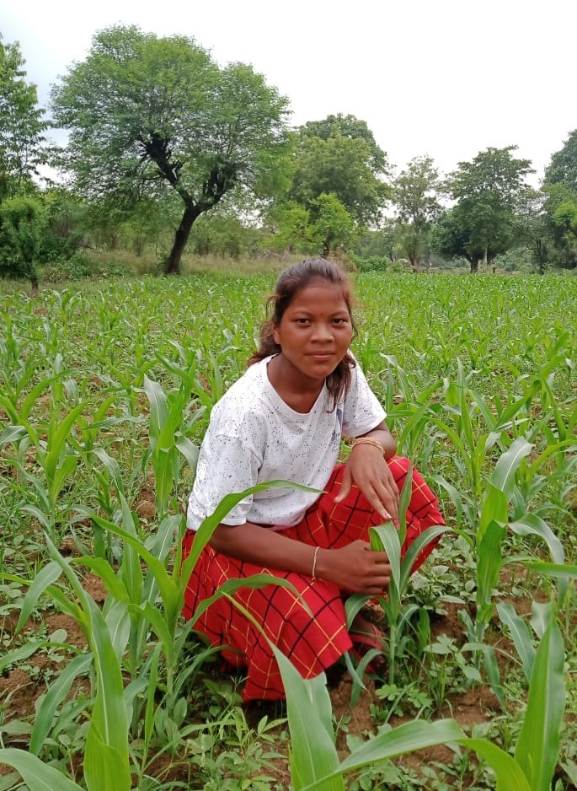

Picture Credits: Ekjut

**TABLE OF CONTENTS**

|  |  |
| --- | --- |
|  | **Page No** |
| **Foreword: Compendium** |  |
| CHAPTER 1: Overview  Background  Nutri-Garden  Summary of the interventions |  |
| CHAPTER 2: Nutri-garden interventions in India |  |
| Guidelines and Instructions  Mapping Nutri-garden Interventions in India |  |
| Action Against Hunger  Azim Premji Philanthropic Initiatives  BAIF: Nutri-garden Interventions in Bihar |  |
| BAIF: Nutri-garden Interventions in Nandurbar, Palgarh, Pune, Ahmednagar and Gadchiroli districts, Maharashtra |  |
| BAIF: Nutri-garden Interventions in Akole block, Ahmednagar district, Maharashtra |  |
| Bihar Rural Livelihoods Promotion Society, JEEViKA |  |
| Consultative Group on International Agricultural Research  Chinmaya Organisation for Rural Development  Ekjut |  |
| Farm 2 Food  GIZ  IFAD: Kodo kutki Initiative |  |
| IFAD: Saat Din Saat Ghar Initiative |  |
| IFAD: Tiranga Thali |  |
| MSSRF: Community Kitchen Garden |  |
| MSSRF: Household Kitchen Garden |  |
| MSSRF: School Kitchen Garden |  |
| Semina Agro |  |
| Vedanta Group: Hindustan Zinc Limited |  |
| Welthungerhilfe |  |
|  |  |
| CHAPTER 3: Individual beneficiary case stories  A step towards self-sufficiency  Chemical Free and Resilient Kitchen Garden  Nutrition sensitive Integrating Farming System (NSIFS) to enhance diet diversity  Jillobai’s nutrition garden - a boon for many in her village in Sheopur, Madhya Pradesh during the coronavirus crisis  Beneficiaries of Khushi Project-Plants for Nutrition  Efforts of Yuvasathi Suresh Purty towards enhancing diet diversity of Ambrai village in West Singhbhum district, Jharkhand  Success Story during COVID-19: Chameli Devi from Barguwan village in Sheopur district appreciating Community Nutrition Garden initiative  Kitchen Garden has changed the Nutrition-intake of Rubi Devi and her Family  Seed Mother Rahibai gets Padma Shri |  |
| **Additional Supplements** |  |
| **Glossary** |  |

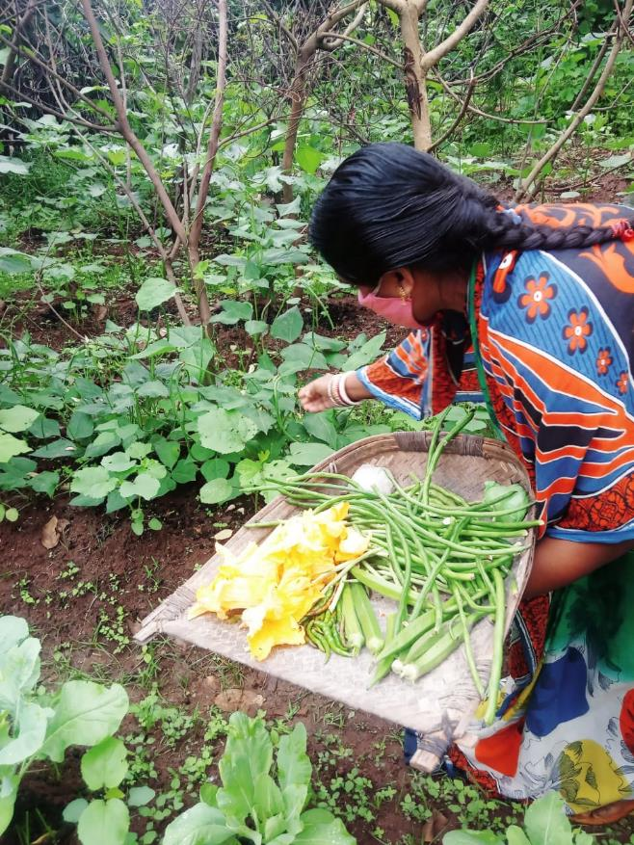

Picture Credits: APPI

**FOREWORD: COMPENDIUM**

Picture Credits:

**Dr Sujeet Ranjan**

Executive Director

**The Coalition for Food and Nutrition Security**

**CHAPTER 1: OVERVIEW**

**1.1 BACKGROUND**

The Sustainable Development Goals (SDGs) replace the Millennium Development Goals (MDGs), which started a global effort in 2000 to tackle the indignity of poverty. Goal 2 of the 2030 Sustainable Development agenda seeks to end hunger and all forms of malnutrition, and double agricultural productivity in the next 15 years. Ensuring this sustainable access to nutritious food universally will require sustainable food production and agricultural practices. As per FAO estimates, year 2017 saw the third consecutive rise in world hunger, with the absolute number of undernourished people i.e. those facing chronic food deprivation increasing to 821 million. One in every 9 people in the world is undernourished. Asia’s decreasing trend in undernourishment seems to be slowing down significantly, with 515 million deemed undernourished in 2017[1].

India has addressed the issue of food access to a large extent, however, undernourishment remains a challenge, indicated by the high prevalence of stunting and wasting amongst children under the age of five. Such undernourishment is on account of complex interactions of several factors like sanitation, genetics, environment and food intake. The Government of India has prioritized strengthening agriculture through measures in irrigation, crop insurance, and improved varieties. The government has also taken critical steps to enhance food security, including through an India- wide targeted public distribution system, a National Nutrition Mission and the National Food Security Act. The Rashtriya Krishi Vikas Yojana, the National Mission on Sustainable Agriculture and many national schemes on horticulture, agricultural technology and livestock are leading the way in improving India’s agriculture1.

Nutrition is the base of human development. It is one of the principal progress indicator of the Sustainable Development Goals (SDGs). Around 35 % of disability-adjusted life-years (DALYs) are lost in children under 5 years of age due to undernutrition. These makes undernutrition the single largest contributor to the global disease burden[2]. The contribution of undernutrition to the global disease burden is approximately two to four times that of pneumonia, HIV/AIDS, malaria and tuberculosis in the general population[3]. One third of the deaths among children are attributed to malnutrition making it an important parameter to gauge the future health of a country. Undernutrition is responsible for the 22 % of disease burden in India[4]. It affects physical and cognitive development of children thereby impacting the demographic dividend of the country. Health impacts due to undernutrition has devastating consequences on the social and economic outcomes of a nation. As per the World Bank report, India losses 2-3 percent of its Gross Domestic Product (GDP) every year due to undernutrition among children in the age group of up to 2 years[5]. The prevalence of stunting, underweight and wasting among the under-5 children in India is 38.4%, 35.8% and 21% respectively (NFHS-2015-16). Around 53.1% women aged 15-49 years and 58.6% children aged 6-59 months are anaemic in the country. It is a matter of concern that adult obesity and overweight is also increasing in India. 20.6% women and 18.9% men are obese (NFHS-2015-16).

An appropriate diet is critical in the growth and development of children especially in the first two years of life[6]. Nutritional status of an individual is closely related to its food consumption pattern, and the World Health Organization suggested that one of the main strategies to improve nutrition is increased dietary diversity at the household level[7]. Dietary diversity is associated with household or individual food availability and intake of nutrients from different food groups and is an important component of nutritional outcome. Greater emphasis has been given by the scientific community on a balanced diet, laying down dietary guidelines to ensure adequate nutrient intake by individuals. In developing countries dietary diversity is given greater importance specially to address nutritional deficiencies[8] and there is widespread recognition that low dietary diversity is associated with chronic nutritional deficiencies[9]. Studies have proved that low dietary diversity has negative consequences for health, immunity, mental health and reproductive and social capacities[10]. For the Indian context, Menon et al. (2015) used nationally representative data (National Family Health Survey 3, 2005–06) to show that dietary diversity of children aged 6–23 months is “strongly and significantly associated with stunting and underweight[11]. As per NFHS -4 data in case of India, with regards to the seven food groups in children in the age group of 6- 59 months, the consumption was the highest for grain, roots, and tubers (74%), followed by dairy products (55%), other fruits and vegetables (37%), Vitamin A rich fruits and vegetables (29%), and the lowest for eggs (14%), legumes and nuts (13%), and flesh foods (10%) in the last 24 hours[12].

The primary aim of the Nutri-garden compendium is to generate an awareness and knowledge on various modalities of nutri-garden and its role in improving food security at various levels (community/ household) by highlighting the extensive works done on this field by some of the organizations/ institutions across the country and highlight individual case stories. Ministry of Rural Development (MoRD) in its directive dated 4th May 2020 has already issued guidelines for promoting Nutri-garden for individual beneficiaries and community in convergence with state schemes and National Rural Livelihood Mission (NRLM)[13]. Key points from the directives includes permissible works listed for individual and community nutri-garden under Mahatma Gandhi NREGS that will help establish nutri-garden for individuals and communities, prioritizing beneficiaries of the ICDS Programme of the Department of Women and Child Development for nutri-garden related activities, necessary dovetailing with related departments for assured supply of vegetables seeds, poultry etc., ensuring necessary convergent planning for effective implementation of nutritional gardens, right selection of perennial plant species under horticulture plantations providing high nutrition and medicinal value for eradicating malnutrition, supporting nutrition garden by leveraging SHGs, community nutri gardens in government run schools including residential schools, anganwadi centres, Gram Panchayat land etc. Also, Ministry of women and Child Development has issued guidelines for leveraging nutrition garden at the anganwadi center during the POSHAN Maah 2020[14].

The nutri-garden compendium is the third initiative by the Coalition for Food and Nutrition Security in generating awareness and knowledge on various aspects of nutri-garden in the country. On 11th August[15] and 5th September 2020, the Coalition for Food and Nutrition Security organized two webinars pertaining to nutri-garden in collaboration with the Centre for Technology Alternatives in Rural Areas (CTARA), IIT Bombay and Asia - Pacific Association of Agricultural Research Institutions (APAARI). The webinars were found to be a beginning in scaling up of the ideas of the Nutri-garden in convergence with the MGNREGA. The need of having a menu of designs and its availability to the larger population was also emphasized in the webinars. The webinars iterated the idea of the nutri-garden compendium, so that it can be shared with several key stakeholders e.g. relevant ministries, various state governments, CSOs etc. so that there is no need to reinvent the wheel and the ideas can be adapted easily.

**1.2 NUTRI-GARDEN**

Nutri-garden is a multidimensional effort to reduce malnutrition. In nutrition context, a nutri- garden is a habitat from which we get nutritionally rich fruits, vegetables and food from livestock sources. Nutri-garden is the growing of nutrient rich crops in residential houses or in their vicinity or in community areas to meet the dietary requirements of the family all year round. Nutri-garden is also known as nutrition garden, kitchen garden, community nutrition garden etc. Vegetables are grown according to seasons by utilizing the locally available wastes and optimized utilization of household backyard/ front yard or community spaces. Once prepared the primary objective of a well laid out nutri-garden is to fulfil the nutritional requirement of the family in form of carbohydrate, protein, fibre or roughage, fats, vitamins and minerals. Nutri-garden is based on diversity in terms of vegetable, fruit, spices cultivation and livestock rearing (Mixed farming approach), and focuses more on soil fertility enhancement in a sustainable organic approach. The efficacy of a nutri-garden can be enhanced via retro-fitting with poultry, goat rearing, diary, fish etc. The main aim of the retro-fitting of nutri-garden is to provide the households with nutrients from fish, meat, egg and dairy products in addition to the nutrients from vegetables. It is always the planning and designing of a nutri-garden which is crucial and not the cultivation practices and maintenance as farmers are already familiar with it and knows it better than anyone. Nutrition garden is an indigenous and sustainable solution to malnutrition and can demonstrate desired changes in the nutrition scenario in the country if integrated with the existing government system such as ICDS. It is a low-cost sustainable approach for reducing malnutrition, increasing awareness of vegetable production, increasing working hours and achieving food, nutrition and economic security.

Nutri-garden can be classified into various types depending on the area, location, production etc. Depending on the location, it can be classified into household/ home and community nutri-garden. A household nutri-garden caters primarily to a family and is a planned space located either in household’s front yard or backyard space to be utilized either for cultivation. The community nutri-garden is leveraged by a group of peoples like Self Help Groups (SHGs) etc. via utilization of a community owned land like panchayat lands etc. for cultivation. Nutri-garden can also be classified on the basis of the types of produce, whether it is vegetarian or non –vegetarian. Classification can also be based on the utilization of the produce of the nutri-garden e.g. self-consumption, selling, value addition etc.

Some of the critical components/ elements of a nutri-garden are as follows:

* Permanent green fence/Temporary brushwood, net fence etc.
* Water source (may be waste water of bathing, cooking etc.)
* Focus on Indigenous seeds (If not available, then Improved varieties) (No Hybrid seed)
* Soil amending inputs like compost and other solid/liquid well decomposed/fermented materials
* Cultivation techniques like raised bed, circle bed, big circle bed, containers for vegetable cultivation
* Horticultural Seedlings
* Small area for vegetable seedling production
* Different organic inputs/solution/extract for disease and pest control
* Phaurah, Spade, Weeder, Rose cane, straw, different containers etc.
* Mulching materials
* Livestock like goat, poultry etc.

**1.3 SUMMARY OF THE INTERVENTIONS**

Around 21 nutri-garden compendiums were received from 15 organizations across India. It was observed from the nutri-garden compendiums collated from the organizations across India, that most of the nutri-gardens are used for only vegetables along with self-consumption and surplus selling.

**Table: -** Distribution of number of model types intervened by the organizations across India



**Key highlights from the collated nutri-garden interventions received are as follows:**

1. **Consensus and awareness generation**

Consensus and awareness generation among the households/ families of the villages is the first and most important step in a nutri-garden initiative. The initial discussion with the households/ families will be cater to their knowledge/ issues reading nutrition and dietary diversity, land holding, water challenges etc. The Gram Panchayat, Mahila Mandal, POSHAN Panchayat, Self Help Groups, and other influential platforms/ federations can be leveraged in mapping of the interested households along with consensus and awareness generation in the village. During the initial phase, it is also important to cultivate the sense of ownership among the households/ families engaged, towards the nutri-garden. The awareness generation and engagement with adolescents & their families together with inputs on the need for improving nutrition at a younger age, especially for girls is strategic. It is also needed to separately engaging the adolescents on issues of health risks & benefits of nutrition to explain the ‘whys & how’s’ of poor health & nutrition.

1. **Input Management**

Input management of the key stakeholders is a critical component of the nutri-garden initiative. The input management needs proper study and survey of the region concern for providing the appropriate support to the households/ families related to water scarcity/ flood, bio-fertilizers, seeds kits, gardening tools, technical training from institutions like Krishi Vigyan Kendra (KVK), compost material & seeds, pest management etc. Also, the households/ families need be trained on the Why, Where and How of the nutri-garden along with the planning and designing of the nutri-garden as per the annual household dietary diversity need and space availability. It is also important to provide timely monitoring/ advisory support to the households/ families. The knowledge on retro-fitting and sustainability also needs to be imparted to the households/ families along with education about the need, importance of balanced nutritional diet & should be encouraged to set up their own nutri gardens.

1. **Sustainability of nutri-garden**

For sustaining and to get the real benefit of the nutri-garden, a strategy for the year-round availability of the vegetables and fruits is critical. The nutri-garden should also include fruit trees for enhancing the dietary diversity and year-round availability of the nutrient rich foods. Also, for sustainability it is necessary to promote group discussion & demonstrations in the community with implementers of the kitchen garden along with peer-to-peer learning between the beneficiaries. Other safe & sustainable agricultural practices promoted includes intercropping, crop rotation, mulching or direct sowing to improve soil fertility & increase yield, multi-layer cropping. For cost effectiveness and sustainability of the nutri-garden retro-fitting with poultry, goat rearing, diary, fish etc. can be leveraged. The nutri-garden plot needs to be divided into several sub beds for growing different vegetables and fruits. Each sub beds can provide vegetables for a day to the family and the family can again sow the seeds in the same bed. This process ensures the year-round availability of vegetables to the families. For the self-consumption of the produce from the kitchen garden there can be innovations like Tiranga Thali to promote consumption of a balanced diet through a simple message to households to include foods of three colours- saffron, white and green - in their diet, where white to primarily represent carbohydrates (rice/ wheat - the flat bread roti/ dairy - milk or curd), green to represent vitamins and minerals (leafy vegetables) and saffron to represent proteins (e.g. pulses, eggs, meat etc.).

For the sustainable availability, variety and quality of the seeds in the nutri-garden initiative at the household and community level, the exchange of seeds, graft & saplings are encouraged among participants/ beneficiaries. Also, a seed bank established at the village or a gram panchayat level housing both traditional and hybrid seeds. The villagers can collaboratively run the seed bank through collection of wide variety of germplasm. The seed bank should house varied and region-specific seeds. The germination testing & physical purity testing can be carried out at the seed bank level.

1. **Post-harvest support for sale of surplus generating revenue**

For revenue generation and sustainability of household and community nutri-garden, the families can sell the raw or value-added surplus (e.g. Kodo/ Kutki bars) in the market. The intervening organization should provide/ advice on the sale of surplus post-harvest in local markets for additional income. There needs to crop diversification, especially for the surplus, so that there is no surplus of only one type of vegetable in the market leading to lower sale price. There can be collaboration with the women & child development and education departments for sale of the surplus to the anganwadi centers and schools for hot cooked meals and mid-day meals respectively. Resource persons or community organizations can also be leveraged for the procurement and training related to the selling of the surplus.

1. **Leveraging MGNREGA**

MGNREGA can be leveraged for the kitchen garden related activities as it supports the components of the nutri-garden. Farmer can buy the necessary materials for the nutri-garden construction from his MGNREGA daily wage, if he/ she works in self land. Bamboos for construction can be sourced under the MGNREGA fund. The goat shed can be constructed with the help of MGNREGA daily wages in a household along with repair and preparation of concrete floor for proper collection of cow dung and urine. A concrete floor will also help in curbing foot and mouth disease in cows. Goat shed and cow shed can be created from the individual household asset creation under MGNREGA.

1. **Urban nutri-garden**

Undernutrition is not only a rural areas problem but also impacts the urban areas in the country. To deal with the prevailing undernutrition in the urban areas, nutri-garden in urban spaces can be promoted, which can be economical and healthy option. Also, the methods used in developing the rooftop or balcony-based nutri-garden are being shared with many people through WhatsApp, telegram and Facebook platform which help thousands of families across 30+ countries to start their own garden.

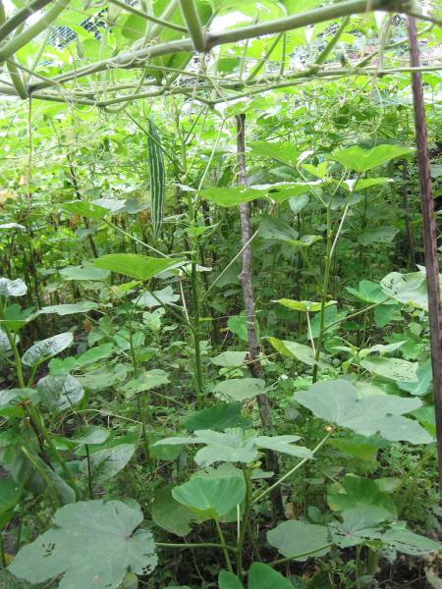

Picture Credits: Welthungerhilfe

**CHAPTER 2:**

**NUTRI-GARDEN INTERVENTIONS IN INDIA**

**2.1 GUIDELINES AND INSTRUCTIONS**

Each organisation was requested to provide their region-specific information on their *flagship/ best interventions on* nutri-garden in a particular format. The format was accompanied with detail notes to guide filling of section wise information. The format for submission was in a single A4 size and divided into different parts which are explained below:

**Part 1: Objectives and Funding support**

1. The nature of support to the Nutri-Garden related project/ intervention e.g. nutrition security, livelihood etc is mentioned
2. Optional: Funding/supporting organization for Nutri-garden project

**Part 2: Standard for Nutri-Garden model**

1. For standardising the different types of Nutri-garden category, following categories based on its scope and level are proposed:
   1. Three types of categories:

* *Category A- Nutri-garden catering to consumption only no sale.*
* *Category B –Individual consumption and selling the surplus produce*
* *Category C–Selling the surplus with value addition through processing*
  1. Three of activities are envisaged as follows:
* ***Level 1 –*** *Only fruits / seeds / vegetables.*
* ***Level 2*** *– Nutri-Garden along with the Backyard Poultry,*
* ***Level 3*** *– Nutri-Garden poultry and other addition e.g. fishery.*

Table 1 Reference table to select an intervention type standard

|  |  |  |  |  |
| --- | --- | --- | --- | --- |
| Standardizing Model Type | | **Activity** | | |
| 1.0 (Fruit/seeds/vegetable) | 2.0 (Vegetarian +Poultry) | 3.0 (Vegetarian  + Poultry + Other) |
| **Category** | A(Only Consumption) | *A1* | *A2* | *A3* |
| B (Selling Surplus) | *B1* | *B2* | *B3* |
| C (Selling Surplus with value addition) | *C1* | *C2* | *C3* |

The above table are referred by organisations for determining the standardisation code of the nutri-garden. For example, as shown in the above table if the intervention of Nutri-Garden is not supported with any of poultry and other nutrition supplying source and the purpose is self-consumption then the model will be of type A1.

**Part 3: Brief description of the nature of intervention**

1. Duration of the project (Start and end date or ongoing date is mentioned)
2. Targeted Population/Beneficiaries & Geographies covered (Number of Districts, blocks, gram panchayat, households etc.)
3. Implementation modalities/structure (carried out independently or in partnership, convergence with Government schemes and Departments)
4. Nature of support/ intervention (Advocacy support/Technical Inputs etc.)
5. Preparatory activities and planning
6. Dietary diversity (Food groups) before and after the intervention
7. Agro-Ecology zone of the area of intervention
8. Malnutrition status of the intervention area
9. Intervention type – (*Individual level/ community level/ school level*)
10. Reference link for any other detailed information

**Part 4: Description on Nutri-Garden design, operations and maintenance**

1. Description of intervention carried out are mentioned (Key components, Type of nutri-garden referred from *standard table from above,* procedures of setting up- plantation, particulars of suggested food items, irrigation, manure preparation, scheduling, maintenance etc, costing of nutri garden)
2. Other qualitative/quantitative design specification, training ppt/videos if any
3. Reference link for any other detailed information

**Part 5: Images**

1. Combination of images are selected (Maximum 4 images or 2 or 1) based on design of the Nutri-Garden, Images of Nutri-Garden at different time frame

**Part 6: Outcomes and Impact of Intervention**

1. Key findings and learnings from the project/ intervention
2. Key challenges faced during design, operations, management, safety and sustainability of Nutri-garden.
3. Results of Impact analysis (qualitative/ quantitative analysis on indicators before and after intervention)
4. If there is a plan for scale-up or mainstream implementation, convergence with Government schemes and Departments and details of the same
5. Reward and Recognition (Awards/ Peer Reviews/ News Articles)

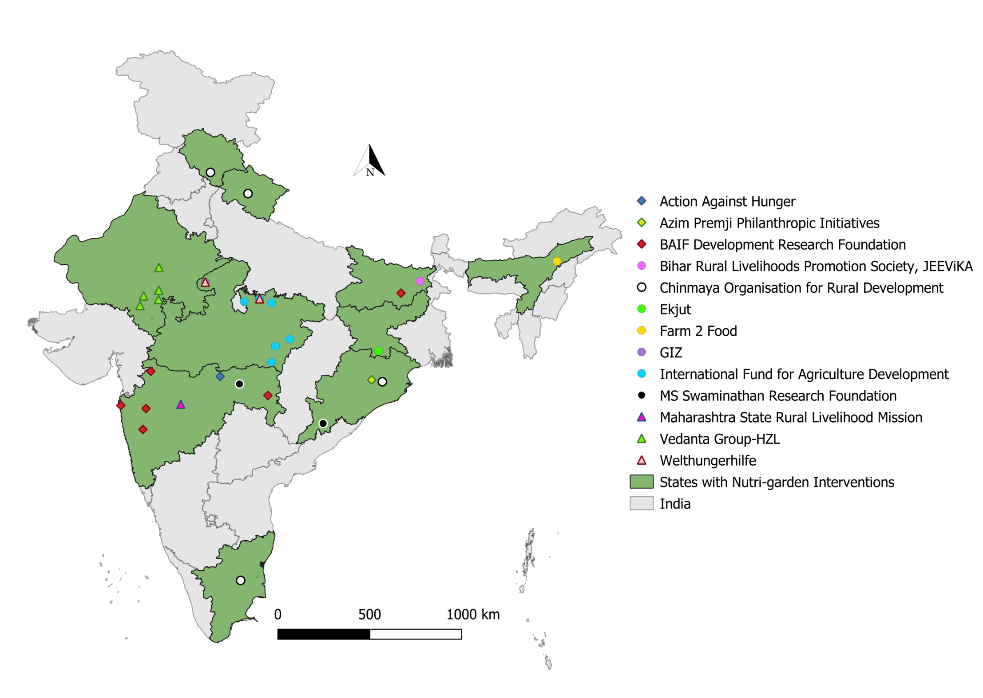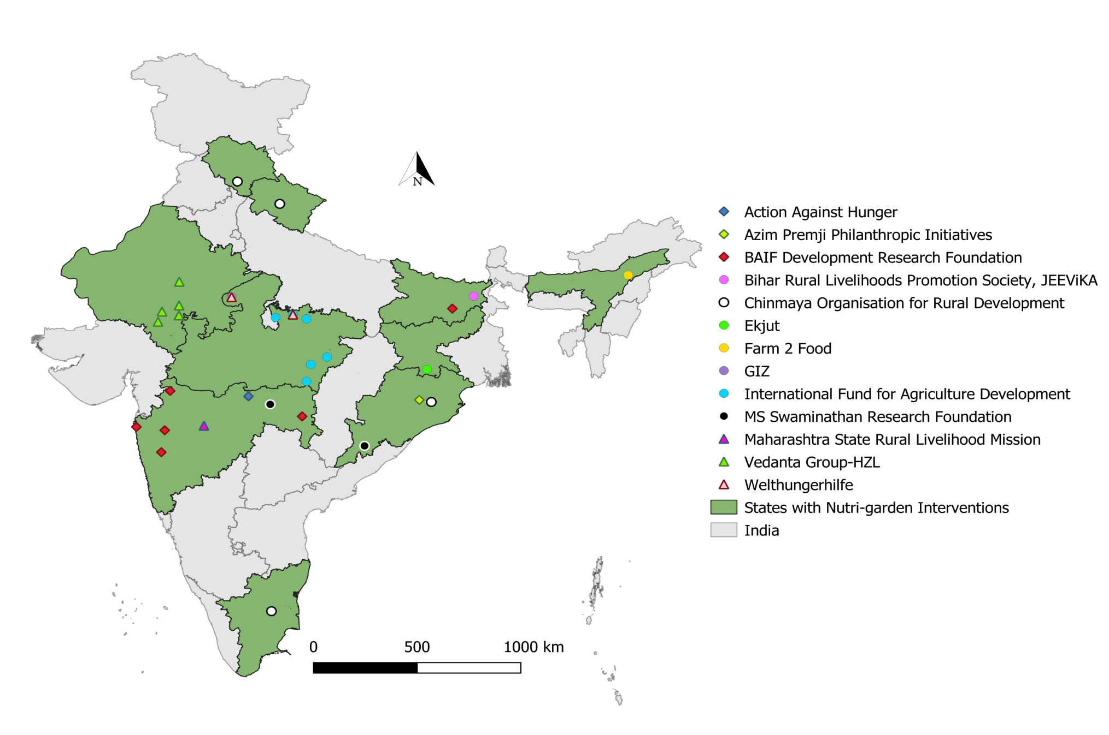**2.2 Mapping Nutri-garden Interventions in India**

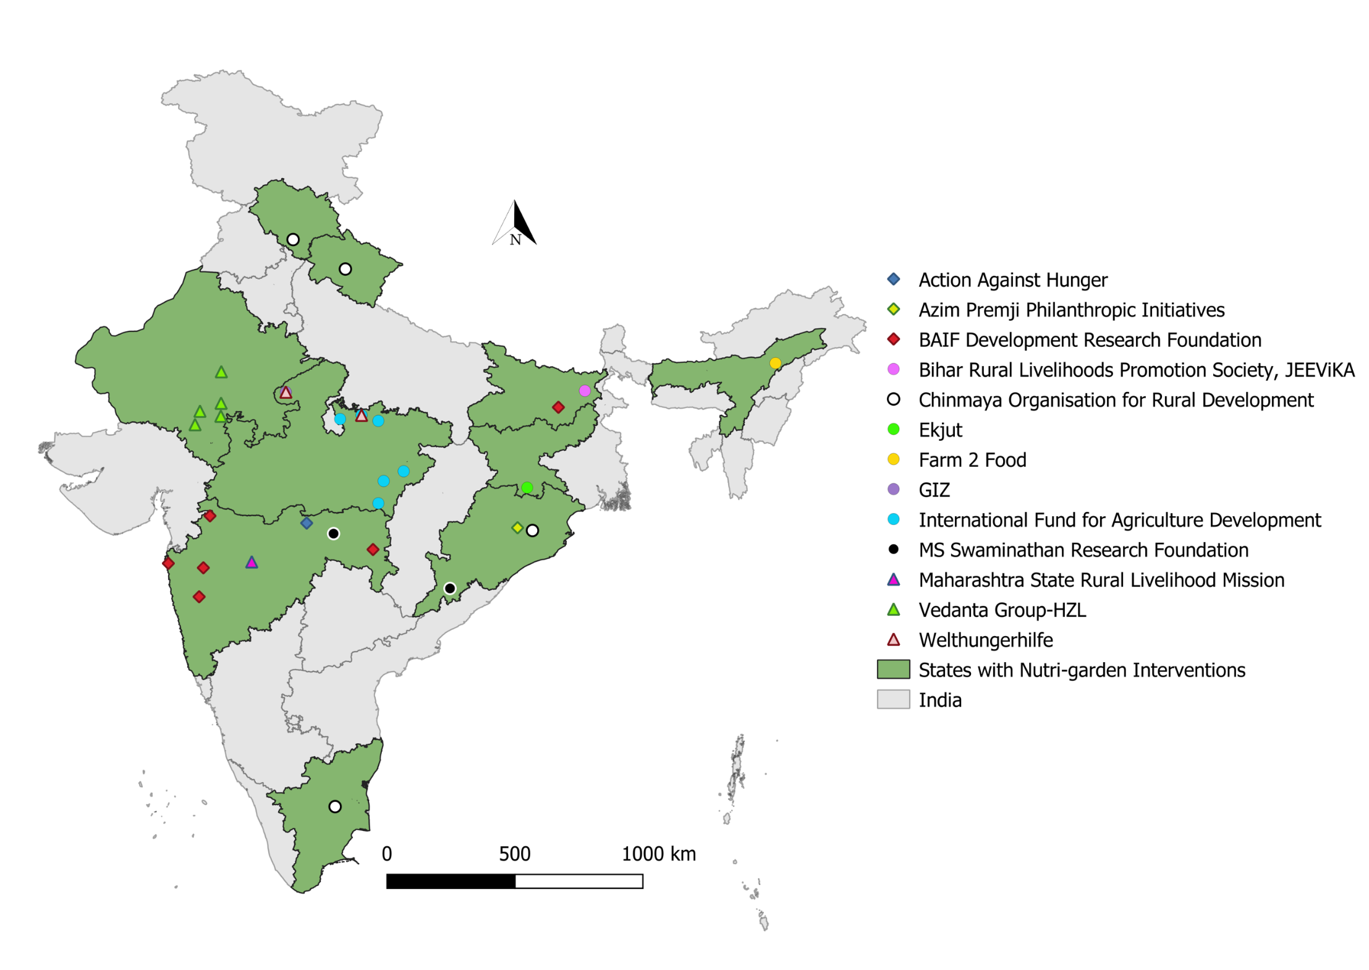







































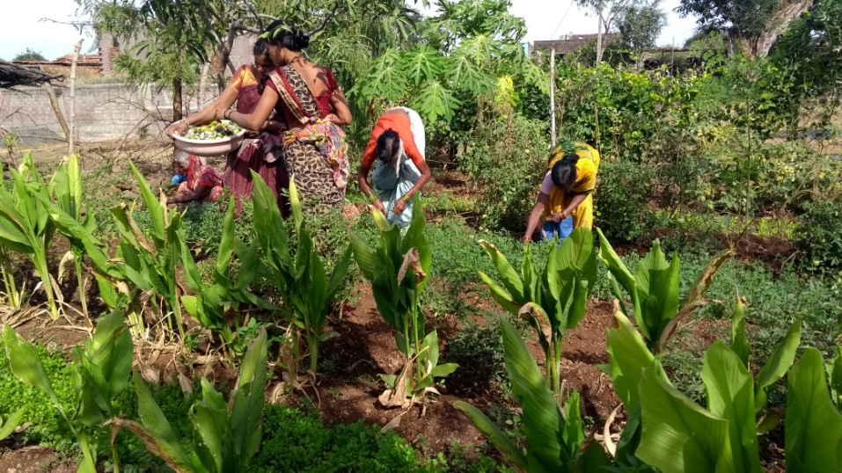

Picture Credits: MSSRF

**CHAPTER 3:**

**INDIVIDUAL BENEFICIARY CASE STORIES**

**A step towards self-sufficiency**

**1**

**Individual beneficiary case story**

This story is about a farmer who with his own efforts attained self-sufficiency in growing diversified vegetables for his family. He resides in Khidki village, situated 25 km away from Dharni (Amravati district, Maharashtra) on hill of 150 ft. steep alleviation. The village faces severe drinking water scarcity and as it is surrounded by a forest, villagers also face the menace of wild animals in their farms.

**Location:** Khidki village, Dharni (Amravati district, Maharashtra)

***Shankhlal Chimote*** a resident of this vulnerable village, has 3 children, all identified with moderate acute malnutrition during the Action Against Hunger India’s screening cycle.

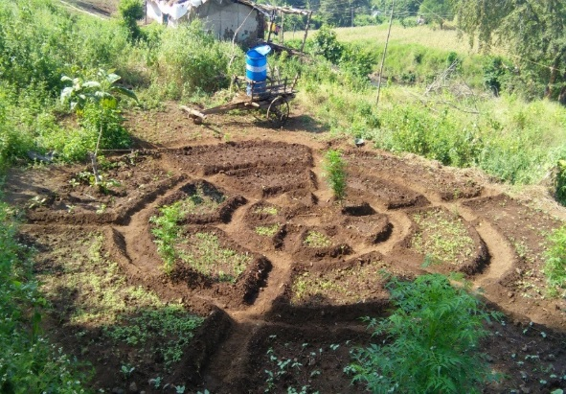During one of the routine discussions on food security and livelihood and its relation with preventing malnutrition, he expressed his willingness to undertake the essential steps required for ensuring good health for his kids.

Subsequently, he was educated and trained on

implementing kitchen garden following which he

enthusiastically agreed to lay out and setup kitchen

garden on his field. He was provided a seed kit and

set up with the layout for kitchen garden. He completed his kitchen garden

sowing in July (2018). In August, the village experienced

a dry spell for 15-20 days due to which he had to fetch

water from a long distance to irrigate the kitchen

garden.

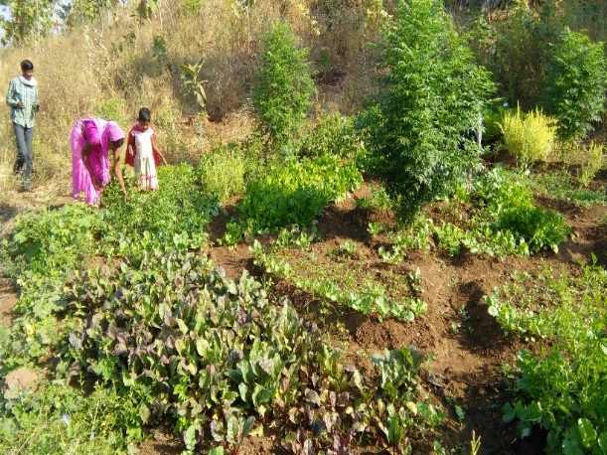He was advised to invest in an electric motor pump that would reduce his drudgery, but could not do so due to financial constraints. However, a month later, with enough produce in hand, he purchased an electric pump by selling some of his farm produce after ensuring enough quantity for his family. With adequate resources in place, he is now able to grow and harvest the vegetables in adequate quantity. He has even actively shared his experience with other villagers and encouraged them to establish their kitchen garden. Even these villagers are now enthusiastic to establish their kitchen garden and are looking forward to growing their own vegetables.

**Chemical Free and Resilient Kitchen Garden**

**2**

**Individual beneficiary case story**

Mon district in Nagaland is among the country's 250 most backward districts. Most of the population depend on agriculture or agri allied activity and are involved in Jhum.

**Location:** Mon District, northernmost district of Nagaland

Nutritious food is difficult to find in poorer rural areas where most people are dependent on staple foods with little diversity (Krishna, 2004; Johns and Sthapit, 2004; Talukder et al., 2004). It is especially a challenge in the far Northern most district of Nagaland, where geographic remoteness, education levels and poor economic conditions are the main obstacles that limit access to green vegetables more so, during rainy season as most of the green vegetables are accessed from Assam.

To disseminate the benefits of kitchen garden and augment the use of organic green vegetables Mon Area Development Programme of World Vision India, in technical association with Semina Agro selected individuals for TOT to orient the importance of kitchen garden in the area.

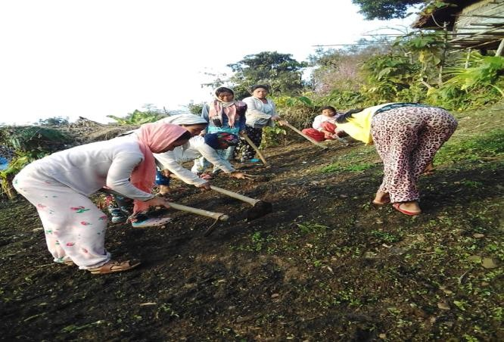Kitchen Garden promoted by Semina Agro is a judicious mix of different vegetables in different season, and raises them in quantities up to 250 kgs per season to meet a requirement of family of five people. Crops is divided into three seasons as rotating these crops as per the season gives a spurt in growth and productivity. The selected beneficiaries were oriented for bed preparation and on the need of plants mineral nutrients. The kitchen garden is a small piece of land of 20’ x 20’ in the backyard with 10 manageable beds of sizes 10’ x 3’. This garden demands the odd 30 minutes or an hour in a day to monitor the general health, progress, and of course the mundane job of irrigation. Semina conducted sessions on scientific and organic farming techniques and now most of the beneficiaries have flourishing gardens and have access to a range of vegetables like French bean, cow pea, peas, amaranthus, sponge gourd, bottle gourd, spinach, basella, cucumber, cabbage, bhindi etc.

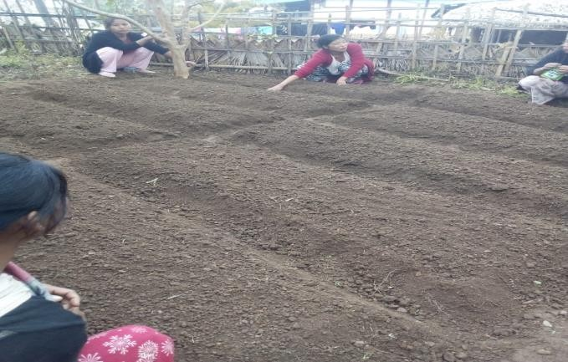

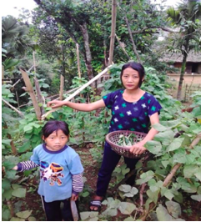Toikam, a beneficiary of World Vision India kitchen garden initiative and a resident of Lamcong Sheanghah village in Mon says,

**“Apart from an increase in income, the kitchen garden initiative also helped me to ensure food security and improve the nutrition status of my child & family. Moreover, my family members are now proud of my initiative”.**

With the guidance I received, I know the value of kitchen garden and at this time of COVID-19 the realization was more as I did not have to buy vegetables from the market and saved money instead, admits Toikam. The gardens improved our social status as well as our awareness with regard to the importance of a healthy diet for our children. For some of us women, we also sold some of our garden products in the local markets, it is also a good source of income.

**Individual beneficiary case story**

**3**

**Nutrition sensitive Integrating Farming System (NSIFS) to enhance diet diversity**

Agriculture over the ages has evolved from subsistence to surplus and thus the nature of farming has also changed from ecological perspective to mono-crop practice with high reliance of farmers on external inputs for production. The blind following of external input-based agriculture has made farming less viable and less rewarding enough to compensate the household dietary requirements in terms of diversity and seasonality.

**Location:** Kachnahar Village, Chak Panchayat, Jalalgarh, Purnea district, Bihar

The NSIFS approach introduced by JEEViKA with technical inputs from Abhivyakti Foundation and UNICEF has raised her (Sushma Devi from Kachnahar) hopes to become an independent farmer.

After the training, she understood about under-nutrition and its remedy. The remedy was to focus on increasing household palate with different variety of food and recipe thereby increasing the diet diversity. She had a 70’x70’ pond which was seldom used to produce fish. The family had production of crops like paddy, maize, mulberry and jute from their main fields apart from some vegetable production in post rainy season and some pigeons at home. Mostly the production sources were from four of the sub-systems viz. crops, trees, pond and birds.

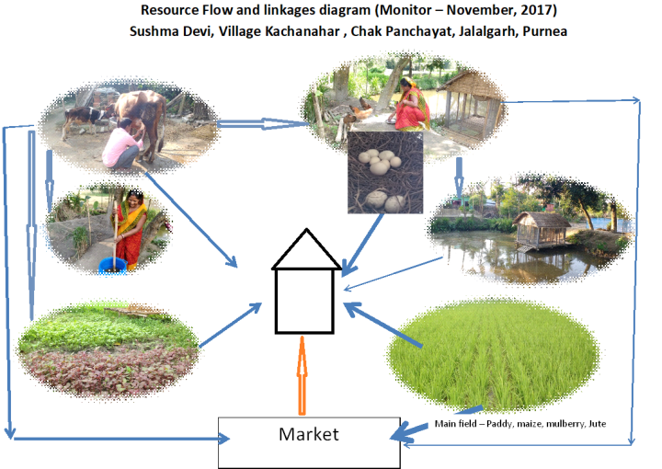

The NSIFS approach helped her to add two more sub-systems animals and bio-digesters apart from expanding the diversity of birds.

The increased income from cow and birds has helped her to invest in developing the nutri- garden more efficiently. Sushma has carefully developed her kitchen garden with green leafy vegetables, other vegetables, vitamin A rich fruits and herbs for regular supply to her kitchen. With composting, liquid manure techniques, use of bio-mass and recycle she has reduced the input cost of farming by one third.

Now convinced with the NSIFS approach Sushma and her husband are helping other small farmers also in their neighbourhood to follow the practice for diet diversity that are available at source i.e. at home.

She has also planted some banana, planktons and guava at home. After setting up all these six sub-systems at home, she is getting sufficient nutrients from different sources at home in the form of eggs, meat, fruits and milk on regular basis now.

She constructed a duck and hen house over the pond and now rearing 15 hens, and 13 ducks from which she is getting 14 eggs every day. The duck and hen excreta directly dropped into the pond has saved her feeding cost of the fish that she has reared in the pond. She has also added 10 more pigeons at home.

She also bought a cow, apart from milk production the cow dung and cow urine are also now efficiently used in making compost and liquid manure for instant use in her fields.

**Individual beneficiary case story**

**4**

**Jillobai’s nutrition garden - a boon for many in her village in Sheopur, Madhya Pradesh during the coronavirus crisis**

Jillobai’s family of five includes her husband, two teenage children and her mother-in-law. Their main source of livelihood is from traditional farming. During the year, they cultivated maize and peanuts in Kharif (monsoon season), and wheat and gram in Rabi season (winter season). Due to lack of knowledge in mix cropping, they had to migrate to nearby towns and cities from March to June, every year.

**Location:** Nayaganv Village, Sheopur District, Madhya Pradesh

Jillobai’s village is among the villages where Welthungerhilfe in collaboration with Mahatma Gandhi Seva Ashram (MGSA) is working create nutrition smart villages with an aim to develop informed village where communities understand ‘nutrition’ & are aware of linkages between agriculture, natural resources, WASH, income & nutrition education.

MGSA under the project, supported Jillobai with learnings of mix cropping and sustainable agriculture. On nearly 0.5 bigha of land which she set aside for a nutrition garden, she now grows a variety of vegetables, fruits and spices such as ridge gourd, pumpkin, tomato, bottle gourd, turmeric and watermelons. This year (2020), produce from the nutrition garden helped Jillobai earn around INR 500 – INR 750 per week. She also had around 50kgs of turmeric production. Jillobai and her family consumes the fresh vegetables and fruits and sells it locally. The produce proved to be vital not only for Jillobai who did not have to migrate during covid-19, but was also beneficial for the locals. She distributed nearly 45kgs of vegetables to her neighbours in pandemic.

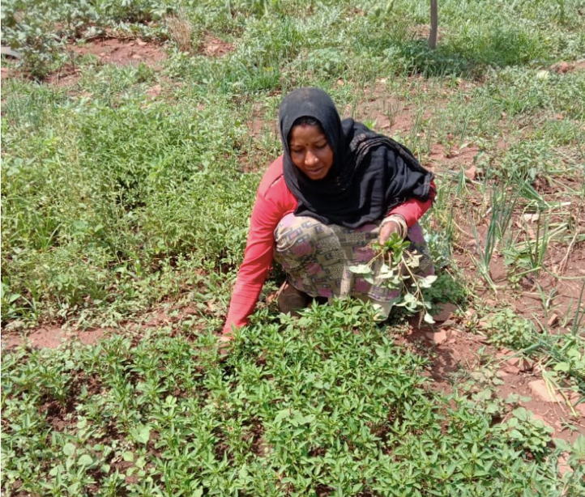

Jillobai, a resident of Nayaganv village Sheopur district, Madhya Pradesh says,

**“Earlier, I did not know anything about mix cropping. But with the help of the team, I set aside a small section of our land and started growing a variety of fruits and vegetables. This year, I am happy that I have enough produce during this time of the year. Otherwise, we would have migrated looking for work”.**

**Individual beneficiary case story**

**5**

**Beneficiaries of Khushi Project-Plants for Nutrition**

**1.**This story is from Dadiya Anganwadi center of Suwana block which is 24 kilometres far from district headquarter. The anganwadi worker Kesar Vaishnav is very active and dedicated towards her work. She established kitchen garden (with the support of Khushi team; Khushi is a flagship project of HZL) in the available space of AWC and provided vegetables to the community members. When the rainy season started Kesar decided to sow new seeds with the help of the community.

**Location:** Bhilwara District, Rajasthan

Community members provided support in the form of seeds, some of them helped in preparing field, sowing seeds. Seeds of Bottle gourd, Pumpkin, Brinjal, Coriander and Tomato along with climber and clipper were sown in the kitchen garden. In the month of September 2020, Pumpkin were produced in good quantity from kitchen garden which was distributed to the needy people of the community during Nutrition month and as well as during events celebrated at Dadiya center.



**2.**In another case study of Khushi Project, Kitchen garden was attempted in the house of a pregnant mother who is also a mother of a malnourished child. She initially refused to establish a kitchen garden in her home premises due to small space and threat of animals. She was advised to build a decent enough structure like a boundary wall with old clothes and planks of trees. She now takes care of the kitchen garden and grows her vegetables.

**3.**This story is from Muhla anganwadi centre which is in Bacchkheda sector of Shahpura block. Muhla village is 22 kilometres’ far from block head quarter Shahpura and 72 kilometres’ far from district headquarter Bhilwara. Ms. Sarita Sharma is an inspiring lady working at anganwadi center from last 10 years. Most of the families are farmers and do animal husbandry in this village. Under Khushi Project when consumption of local home-grown vegetables was promoted, anganwadi worker Ms. Sarita was inspired and decided to grow one such kitchen garden at her anganwadi center. She planted the vegetable at her anganwadi but due to lack of security, kitchen garden was destroyed.

****Her efforts for the first time were in vain. Ms. Sarita found that people threw the waste around the anganwadi center. She realized that without ensuring safety, there was no meaning to establish kitchen garden. She decided to solve the problem and with help of Khushi cluster coordinator Mr. Sohan Bairwa she organized community meeting at anganwadi centre. In the meeting Ms. Sarita shared the problem before community members.

In this meeting, community members

decided to ensure safety though fencing

around the anganwadi centre with

community contribution. With support of

community people, fencing was done

around the AWC. Now the kitchen garden

is safer than earlier.

Now, Ms. Sarita is growing vegetables in her kitchen garden and distributing it to pregnant, lactating mothers in the community. During the COVID-19 pandemic, Ms. Sarita distributed vegetables to the community.

Before starting the kitchen garden, a feasibility survey is done to ensure its yearlong survival. The prerequisites for choosing an AWC for establishing kitchen garden are mainly availability of enough water, open and the fertile area and boundary wall for the protection against animal along with Consent of AWW for the sustainability and maintenance of the garden. Seeds of Bottle gourd, Brinjal, Reddish, Coriander, Spinach and Tomato along with climbers and creepers are sown in these gardens.

**Efforts of Yuvasathi Suresh Purty towards enhancing diet diversity of Ambrai village in West Singhbhum district, Jharkhand**

**6**

**Individual beneficiary case story**

**Suresh Purty** is a Yuvasathi who facilitates monthly adolescents’ group meetings in his village Ambrai for the last three years. His interest in agriculture and knowledge about indigenous trees, floras and faunas helped him to be included in the trainings on organic farming practices and improved farming techniques.

**Location:** Ambrai village, khuntpani Block, West Singhbhum District, Jharkhand

He used to grow paddy in the traditional broadcasting method, but in 2017 he started System of Rice Intensification (SRI) method of paddy cultivation in 20 decimals of land where he got four quintals of paddy and Rs.5,200/- as income. The next he did this in 35 decimal* of land and with an investment of Rs.2,000/- and he got 7.5 quintals yield with a profit of Rs.9,000/-.

As a keen member of the Kisan Samiti, he not only encouraged and motivated other farmers for adopting SRI methods, but also engaged with adolescents for kitchen garden and vegetable cultivation as a part of the nutrition cycle in the participatory learning and action (PLA) meetings where one of the strategies was to develop their own kitchen gardens. Suresh says, now in Ambrai village almost every family has a kitchen garden and the adolescents are consuming their own grown organic vegetables

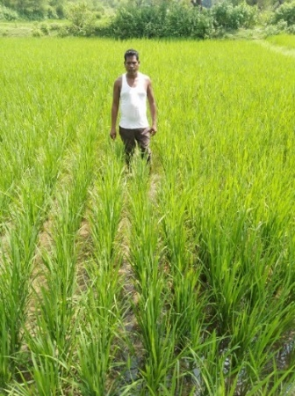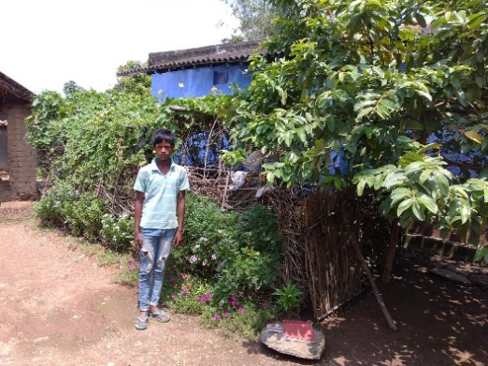

**\*Note: -** 1 decimal equals to 436 sq. ft. or 40.5057 m2. It is approximately equal to 1/100 acre.

**7**

**Individual beneficiary case story**

**Success Story during COVID-19: Chameli Devi from Barguwan village in Sheopur district appreciating Community Nutrition Garden initiative**

**Chameli Devi** informed that, had there been no garden they would just have eaten chilly, onion with chapatti due to lack of income during lockdown. Not only her, other self-help group (SHG) members of the Community Nutrition Garden are also getting fresh vegetables. Chameli appeals to stay healthy by keeping their family meals nutritious and balanced.

**Location:** Barguwan village, Sheopur district, Madhya Pradesh

She is part of the Community Nutrition Garden initiative by GIZ FaNS project for the last 10 months. She belongs to scheduled tribe and has a minimal source of income. During this difficult COVID-19 pandemic time, where many community members in her village feel helpless and stressed about the situation, she remains confident and does her bit in spreading awareness on COVID-19 in her hamlet with the knowledge gained during SHG workshops conducted by a Poshan Saheli.

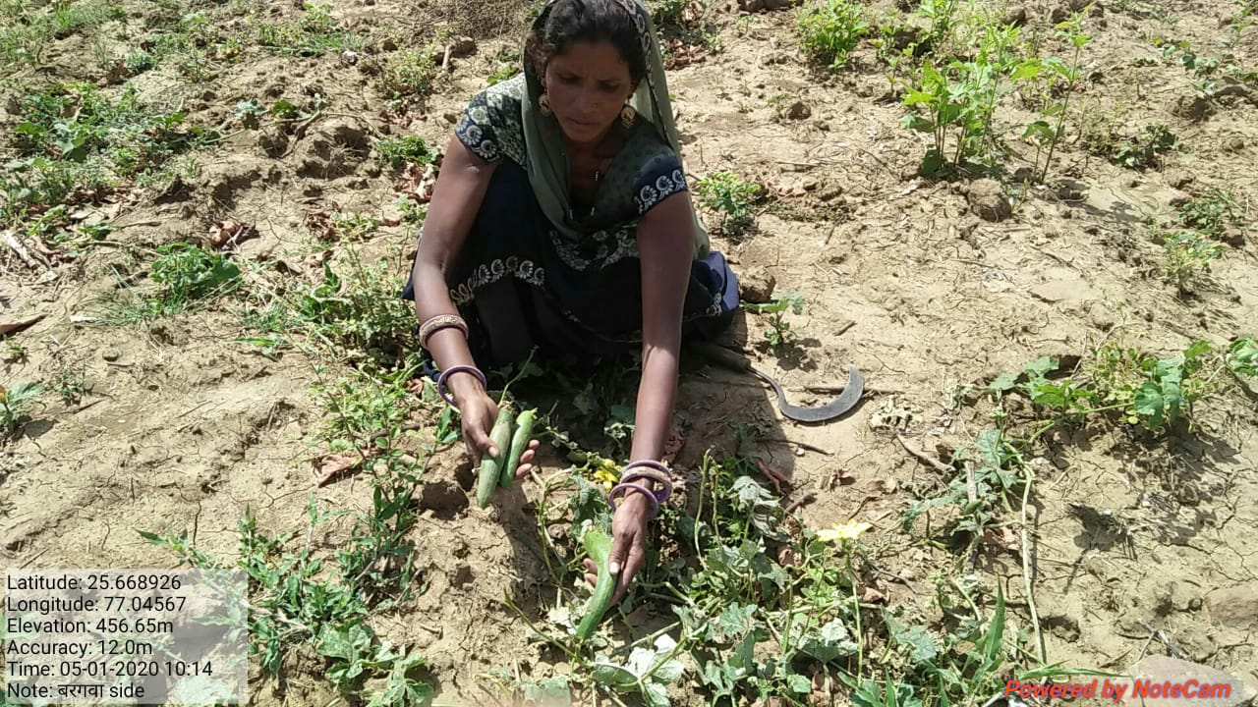

**“I am glad that during this lockdown period I could add nutrition value to my family’s meal with the help of the community nutrition garden. I have worked hard in taking care of the plants and now I do not have to worry about the fresh vegetables as it is right here”**

Contact: nadine.bader@giz.de

**Kitchen Garden has changed the Nutrition-intake of Rubi Devi and her Family**

**8**

**Individual beneficiary case story**

**Background**

Rubi Devi is a member of *Seema Self Help Group (SHG)* in Dasrathi village of Dharhara block in Munger district of Bihar. She has 4 children and her husband has migrated to Delhi for job. In 2017 she became member of BAIF and started working as a Prerak Didi in the organization.

**Location:** Dasrathi village, Dharhara block, Munger district, Bihar

She has completed her training with BAIF on kitchen garden and started her kitchen garden in her own 2 kattha* land as per the guidance received from BAIF under TARINA project. After the training, she is now helping her village group members in issues related to kitchen gardening.

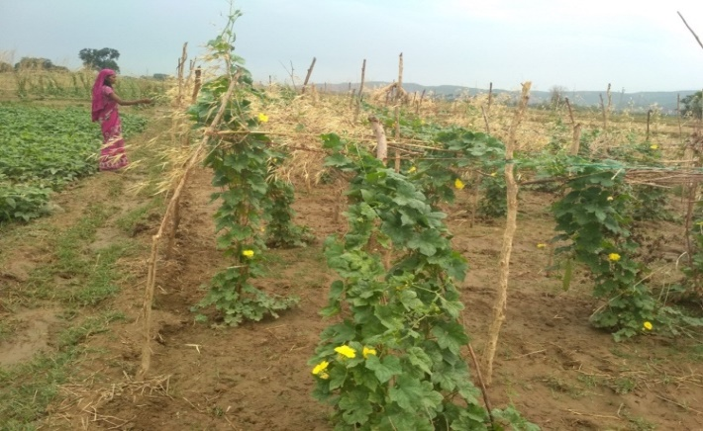

**She says that-**

**“Being illiterate has not bothered me to earn money and support from BAIF gives me more way of possibilities”.**

She also said that earlier she was only growing potatoes and onions from her land with occasionally purchase of vegetables. Since it was too expensive to purchase vegetables from markets, so most of the time she use to feed potatoes to her family. After intervention by BAIF under TARINA project she was encouraged to develop her garden properly. Now she has a range of vegetables and fruits in her kitchen garden namely bottle gourd, sponge gourd, beetroot, carrot, bitter gourd, green chilis, radish, cucumber, lady’s finger, spinach, fenugreek (Methi), beans, coriander, lemon, drumstick etc. As she says that “with the vegetables, which I now get from my kitchen garden, I am able to take care of health of my family”. She also tries her best to ensure that everyone in village maintain a nutritious diet. She usually sells vegetables to her neighbors and to the *Haat (hatia)* which is a local market in the village.

*Note: - 1 Kattha is generally equal to 1361 ft²

**Challenges**

Rubi Devi mentions that the main challenge was of irrigation water. After having the solar and Tullu pump in her village from BAIF, she is able to irrigate her kitchen garden on regular basis. Still, there are challenges related to irrigation of the crops on the villages as the water tables is gradually reducing.

**Impact**

Rubi Devi earned Rs.4000 from 2 Kattha of land in a season and used it is as an asset creation i.e., she bought jewelry for herself. She also mentions that she could have earned more but at that time her father expired, which kept her engaged. She informs that earlier she used to have mostly potatoes in her plate but now they have at least 2 vegetable in plates of her family on daily basis. She has also cleared her due savings in SHG from Rs.400 earned through selling of saag (green leafy vegetables) from her kitchen garden. She has also started saving and spending her earning towards her children education.

The initiative of generating awareness and providing training related to kitchen garden has not only helped the poor to address their nutritional needs but has also helped them to make some money from the surplus produce sale.

**SEED Mother Rahibai gets Padma Shri**

**9**

**Individual beneficiary case story**

**Location:** Kombhalne village, Akole tribal block, Ahmednagar district, Maharashtra

**Rahibai Soma Popere** is a 52-year-old tribal farmer from Mahadeo Koli Tribal community from Kombhalne village of Akole tribal block in Ahmednagar district of Maharashtra. She could not attend school due to poverty and started supporting her family in agricultural work in agri labor and cow rearing since she was 10 years old. She got married with Soma Popere, who was also uneducated, at the age of 17 years. The whole family was dependent on agriculture. Although she had not attended school, she learnt about agro-biodiversity, wild food resources, and traditional culture through practice and experience.

Through her experiences, she realized that the conservation of agro-biodiversity and wild food resources is the need of the hour to achieve seed sovereignty and nutritional security. She started a nursery of Blackberry and distributed them as a gift to members of the Self-Help Group (SHG).

She then established a nursery of hyacinth bean seedlings, rice, vegetables, beans landraces and shared them with 210 farmers in 7 villages of Akole Block. She also conserved and multiplied about 43 landraces of 17 different crops (Paddy, hyacinth bean, millets, pulses, oilseeds, etc.) by establishing an in-situ germplasm conservation center. She has also established a perennial kitchen garden for house-hold consumption and year-round use. Popere is an active member of Kalsubai Parisar Biyanee Savardhan Samiti, Akole, and has established a community seed bank in her small house for conservation and revival of crop diversity and wild food resources.

At present, about 122 landraces of 32 crops are under conservation. She has the zeal to learn new agronomic techniques. She developed expertise in the SRI method of paddy cultivation, improved cultivation practices for tomato and hyacinth bean, introduced participatory seed selection, organic farming techniques (vermicomposting, vermiwash and natural pest repellents), nursery establishment and trained about 3500 farmers across Ahmednagar district. She leads 5 Self Help groups in Kombhalne village and is creating awareness among women for participation in the Self-Help group movement, village sanitation, clean kitchen, seed conservation, and wild food exhibitions. Her work has drawn a lot of visitors-agriculture officers, scientists, farmers, students from different parts of Maharashtra who came to see her in-situ conservation center, hyacinth bean diversity center, kitchen garden, etc.

**Rahibai Soma Popere**, now popularly known as SEED Mother for conserving indigenous seeds and associated with BAIF Development Research Foundation, a Core Support Group of Department of Science & Technology (DST), has been conferred fourth highest civilian national award **Padma Shree for her contribution in the field of agriculture**.

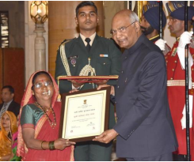

She has worked for conserving hundreds of native varieties and encouraging farmers to grow traditional crops. She has also made it a motto of her life to spreading awareness about organic farming, agro-biodiversity, and wild food resources.

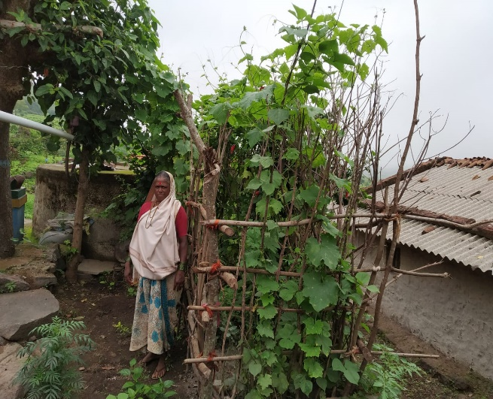

Picture Credits: BAIF

**ADDITIONAL SUPPLEMENTS**

1. **Azim Premji Philanthropic Initiative (APPI)**

**Different Model of Nutrition Garden as per Family Size:**

* **1 Cent model** (435.6 Sq. ft. area): For a family of 2 adults and 1 child (*3 family members*)
* **2 Cent model** (871.2 Sq. ft. area): For a family of 3 adults and 2 children (*5 Family members*)
* **3 Cent model** (1,306.8 Sq. ft. area): For a family of 4 adults and 3 children (*7 Family members*)
* **4 Cent model** (1,742.4 Sq. ft. area): For a family of 5 adults and 4 children (*9 Family members*)
* **5 Cent model** (2,178.0 Sq. ft. area): For a family of 6 adults and 5 children (*11 Family members*)

**N.B.:** From 1 Sq. ft. area, 2-2.5 gm of green vegetables can be collected per day. Average vegetable cultivation area is 60 - 65% of total garden area. Rest 35 - 40% area is utilized for horticultural plantation, walking path and organic manure preparation.

**Example:** If family members are 5 (3 adults and 2 children), then 2 cent area is sufficient to get optimum amount of green vegetables per day during the growing period. Suppose he/she cultivates vegetables in 5 cent area, then he/she can distribute the surplus to his/her neighbours after fulfilling the family needs or can sale the surplus or use for other purpose.

**Container Vegetable Nutrition Gardening**

Container gardening is the process of growing plants in containers instead of planting on the ground. Vegetables can be grown in different containers like jute sack, plastic sack, plastic bucket, partially broken or old earthen pot/vessel, wooden box etc. As containers are portable, they can be transported to other places. Container gardening is ideal for those families who are landless or with limited land. At least 2-3 sacks are required for a person to get required amount of vegetables per day. For a 5 member’s family, 10- 15 sacks will be required to get optimum amount of vegetables per day.

In rural areas, no cost technology of preparing the growing medium for container gardening is the mixture of soil, rice bran and FYM or Compost in 3:1:2 ratio. After mixing, the mixture is dried under partially shade condition for 3-4 days. Then the container is filled with the mixture. There has to be at least 3-5 nos. of small holes under the container for proper drainage of water.

**Circle Bed Nutrition Garden**

It is one of the no cost techniques of vegetable production system. It requires at least 1-2 days to prepare a big circle bed with compost pit at the center, surrounded by 14 nos. of small plots for raising different vegetable & herb plants. Kitchen scraps, leaves & weeds without seeds & roots can be placed in the center. An occasional layer of cow dung will help to keep the compost forming (accelerates composting process) & a layer of straw on top will keep it moist. Usually heavy water duty vegetable plants are sown towards the center. Low water duty vegetables are sown towards the plots nearer to periphery region. From 1 big circular bed of area 706 sq. ft., 900-1200 gram of vegetables can be collected per day. At least 10-12 types of vegetables can be grown in a big circle bed.

**Container Vegetable Nutrition Gardening**

In rural areas, no cost technology of preparing the growing medium for container gardening is the mixture of soil, rice bran and FYM or Compost in 3:1:2 ratio. After mixing, the mixture is dried under partially shade condition for 3-4 days. Then the container is filled with the mixture. There has to be at least 3-5 nos. of small holes under the container for proper drainage of water.

**Advantages of Container Nutrition Gardening**

It is a hope for the landless families who have either very less or no backyard / front yard area adjacent to their houses. Extent of risk is very less in comparison to cultivation on ground. Use of seeds is very economic unlike sowing on the ground in large patch. It either requires very less space on the ground where we keep the container or no space for hanging containers. Less risk of diseases, mostly soil-borne disease is not seen. Suppose a plant in a container garden gets infested with disease, then it is less likely to spread to all other plants in the garden. Also weed problem is not seen and if seen, then it can be controlled manually by uprooting the entire weed. Water management in a container garden is not a problem like vegetables grown on the ground.

**Disadvantages of Container Nutrition Gardening**

Container vegetable gardening can fulfil the requirement of vegetables to some extent but may not fulfil the requirement in macro-level. Jute sack used is prone to tearing, mostly during rainy season. Similarly, hailstorm or throwing stones to earthen vessel may be a threat. Small containers may not encourage the growth of plants like gourds properly, as the root system may be arrested due to space constrain. There may be risk of theft as the containers are light & portable.

**Circle Bed Nutrition Garden**

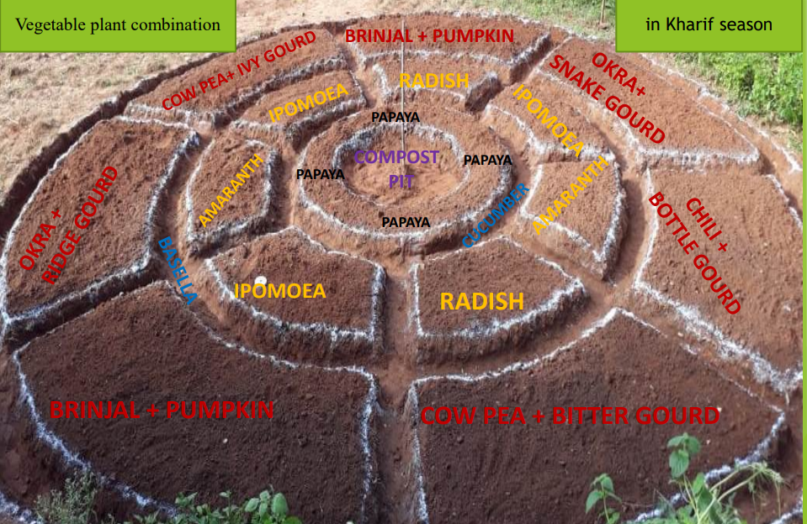

**Concept and evolution of the Mo Upakari Bagicha (MUB) program:**

Malnutrition is a very serious issue in Odisha. Despite progress in malnutrition reduction in the State, 34% of children under 5 years of age remain underweight and 34.1% remain stunted (NFHS-4, 2015-16). With growing understanding of the complexity of malnutrition and its multi-factorial causes, there is a compelling need to move towards adopting and promoting a multi-sectoral approach in order to achieve better nutrition outcomes.

Honourable Chief Minister envisaged to eradicate this problem and Azim Premji Philanthropic Initiatives (APPI) along with ten departments working closely to achieve the goal in coming 8-10 years. Odisha Nutrition Action Plan (ONAP) is prepared and nutrition Secretariat is also established. Through ONAP (Odisha Nutrition Action Plan), it will strengthen Institutions (like ICDS) using the route of community mobilization, empowerment and data management for service delivery of nutrition services and strengthening service delivery of care to the mother and child by leveraging existing state government schemes. While it will promote technical interventions and innovative approaches, it will also create proofs of concept of new interventions and enhance areas of downward accountability and quality of services through credible partnerships.

Odisha Livelihood Mission under Panchayati Raj and Drinking Water Department, Government of Odisha, in collaboration with Azim Premji Philanthropic Initiative (The Philanthropy) has initiated a Nutrition Sensitive Program (later renamed and launched as Mo Upakari Bagicha) across Odisha to address dietary diversity among women and children. This special initiative is likely to mobilize 7.5 lakh household across Odisha through promotion of Backyard Nutri garden, Back yard Poultry and Goat rearing. These gardens to be created by each house hold themselves in 1-2 decimal of land for producing round the year vegetables and fruits, for self-consumption especially by children, adolescent girls, pregnant women and lactating mothers.

**Concept and evolution of the Mo Upakari Bagicha (MUB) program:**

These gardens are designed to focus on providing dietary diversity, by production of 13 different types of vegetables, 4 different types of fruits, essential for women and children based on the food groups. Back yard poultry and goat rearing are additional steps being taken to enrich nutri-garden and provide dietary diversity to households. It is expected that 2.5 Lakh or more households will practice nutri-garden, consume fruits, vegetables, eggs and meat, through a massive awareness building program to be executed by 9-13,000 community cadres associated with Gram Panchayat level federations organized by Odisha Livelihood Mission.

**Implementation Structure and Progress so far:**

* The Philanthropy supported the NGO Living Farms who developed and demonstrated a proof of concept related to nutri-garden and PLA-LANN (Participatory learning and action-linking agriculture to natural resources and nutrition) which can be scaled up the government.
* The Philanthropy and Odisha Livelihoods Mission agreed to work together to tackle the health and nutrition issues as mentioned in “DASA SUTRA” and replicate the nutri-garden and PLA_LANN with SHG as the primary Institution.
* Two more resource NGOS (RNGOs), Harsha Trust and PRADAN identified who were having similar experience in Odisha.
* The Philanthropy facilitated all three RNGOs to develop a common understanding and propose a simple and scalable model that can be implemented through OLM’s SHG systems.
* There are three major components of MUB program e.g. PLA-LANN, nutri-garden and livestock (back yard poultry and goat rearing). RNGOs has developed 14 weekly modules which will be delivered in 14 weekly SHG meetings spread across year. These modules are related to various nutrition specific and sensitive thematic issues. The main objective of PLA-LANN modules are to build knowledge, awareness and practice among SHG members.
* The 14 weekly modules will be delivered to 7.5 Lakh households through 75000 SHG. And at least 2.5 Lakh Nutri gardens (Mo Upakari Bagicha) to be developed covering all the designated vulnerable groups.
* The 14 weekly modules will be delivered to 7.5 Lakh households through 75000 SHG. And at least 2.5 Lakh Nutri gardens (Mo Upakari Bagicha) to be developed covering all the designated vulnerable groups.
* Philanthropy along with OLM and three RNGOs visited BRLPS, Bihar and other areas to understand the concept better and further strengthen the model for OLM.
* Four proposals were prepared one for OLM as primary implementer and one for each RNGOs with a common result framework. Clear role of OLM, RNGOs and The Philanthropy was finalized and written.
* MoU between The Philanthropy and OLM signed in June, 2018 and the Philanthropy agreed to provide both funding and other support to OLM and three RNGOs for three years.
* Dedicated nutrition vertical with 7 state level staffs and 90 district level staffs was planned. All the state level staffs joined in Oct, 2018 and all of them oriented about the program.
* For building the capacity of community cadres, 240 Master trainers have been identified and trained on specific modules of Back yard Nutrition garden, Livestock (poultry and goat) by three resource NGOs.
* The Programme is going on in all 30 districts of Odisha and initially in 107 blocks. There are two types of implementation strategy. In 47 blocks RNGOs have placed their dedicated resource person to OLM called Block Level Resource Person (BLRP). In rest 60 blocks RNGOs are supported as per the need of OLM district and block teams.
* Field implementation of Nutri garden started in kharif, 2019(May/Jun) with 33,000 SHG members.
* This year Govt. of Odisha has included nutri-garden as one of the activities under MGNREGS and allocated additional resources to establish 5 lakh nutri-garden all across the state. Here extra features of one water storage pit, a separate compost pit and fencing with an entrance gate was provisioned in addition to earlier features of both the circular and rectangular model being done earlier. So, 33-man days is provisioned from MGNREGS.
* In this current kharif season (2020), OLM has already established more than 2 lakh nutri-garden.
* All SOPs and guidelines issued to all the districts for establishing nutri-garden, livestock, PLA-LANN and MGNREGS.

**Different components of Mo Upakari Bagicha are as follows:**

1. Nutri-Garden (3 models)-No chemical, only indigenous seeds and focus on consumption are the three nonnegotiable.
2. **Rectangular Model:**
   * 7 rectangular beds 20ft X 3.5 ft. each
   * 4 circular pits at 4 corners to serve as compost pit as well as to grow some vegetables around it with staking
   * 2 lemon, 3 banana, 3 drumstick and 2 papaya plants to be planted around the Nutri garden.
   * Total Area of Nutri garden is 872 sq. feet (2 cent) which gives 1500 to 1800 gram of vegetables each day to a household

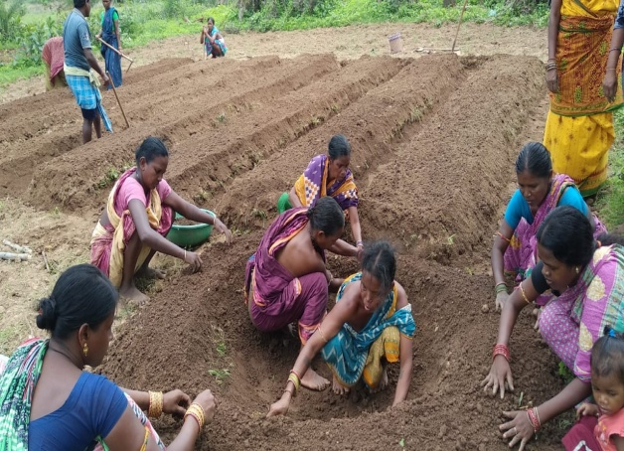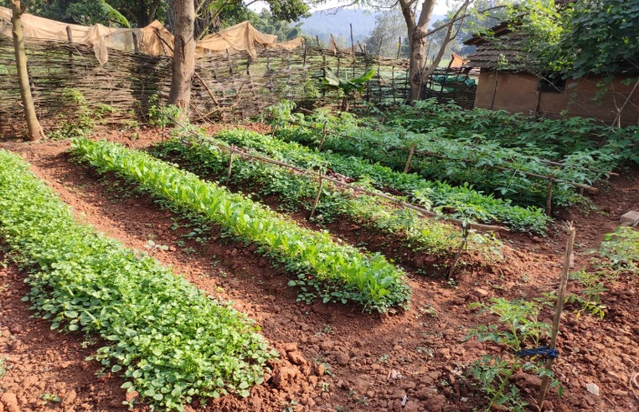

1. **Circular Model:**

* One compost pit at the center
* 7 bigger beds and 7 smaller beds
* 2 lemon, 3 banana, 3 drumstick and 2 papaya plants to be planted around the Nutri garden.
* Total area of Nutri garden is 706 square feet (1.6decimil) which gives 1000 to 1200 gram of vegetables every day to a household.

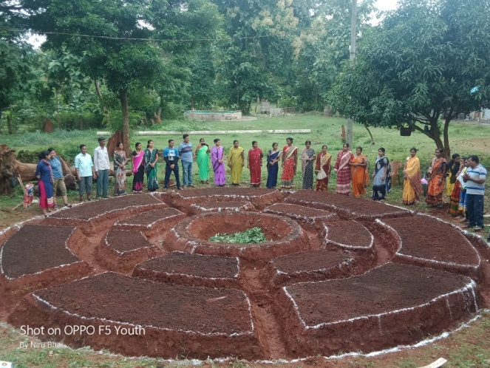 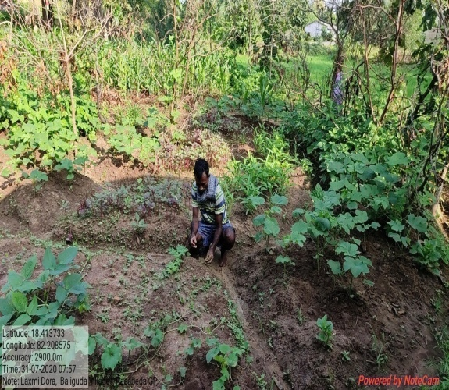

**c.** Land Less model

* Vegetables to be grown in Gunny Bags
* Suitable for Land less people

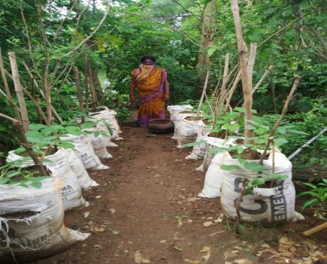 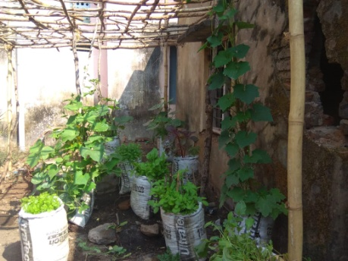 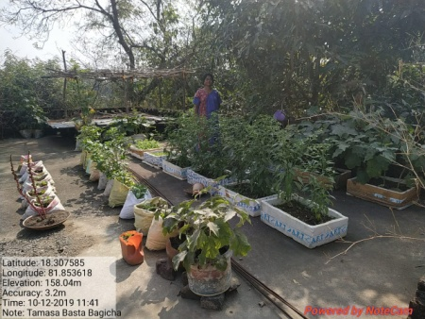

1. **Back Yard Poultry and Goat Rearing:**

* To work with existing Desi birds. 5 hens + 1 cock model
* A proper night shelter and day time confined grazing area
* Clean drinking water and supplementary poultry feed for the birds
* Regular deworming and vaccination
* Goats(5does+1buck) are reared with raised platform
* Timely deworming and vaccination are ensured

**Back Yard Poultry and Goat Rearing:**

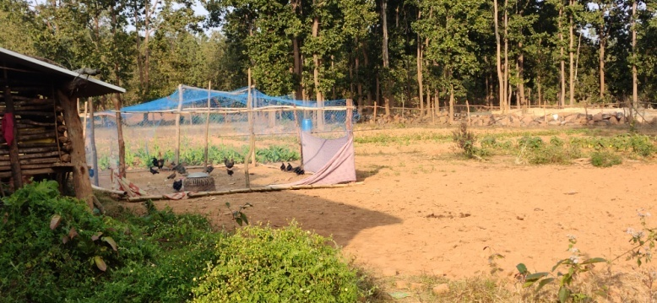 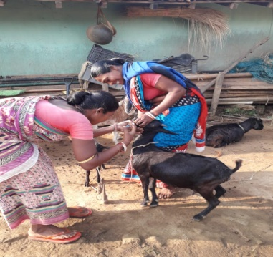

1. **PLA LANN (Participatory Learning and Action, Linking Agriculture & Natural Resources with Nutrition)**

* Out of 52 weekly meetings of SHG in a year 14 weeks are dedicated for PLA LANN Meeting
* Meetings are so designed to self-motivate the SHG members to go for Nutri garden even without financial support from government.

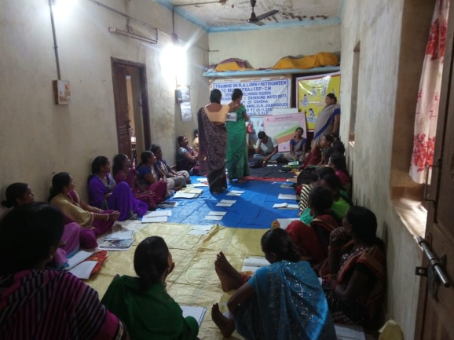 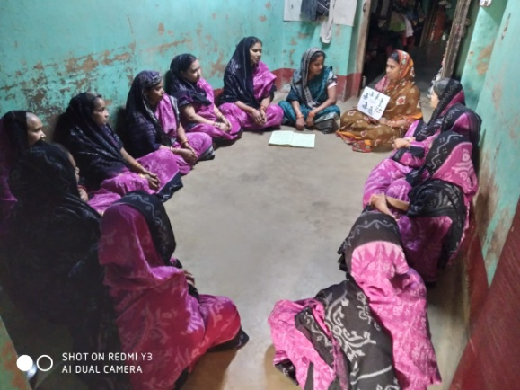

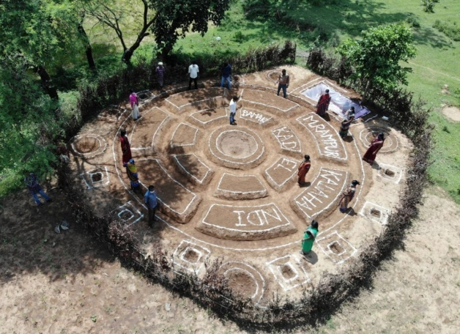 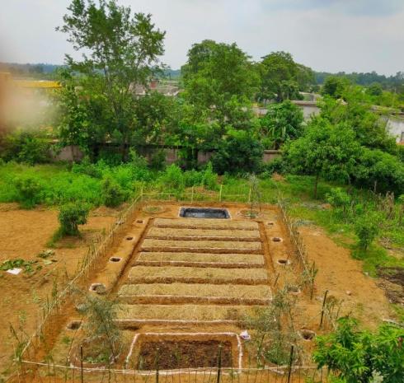

**Learning from the MUB Program: -**

* SHG is a right vehicle for implementation of the program as envisaged.
* Cascading mode of knowledge transfer and building people to build people seems to be a good strategy for sustainable program implementation.
* Dedicated nutrition team within OLM is observed to be a proper strategy for program roll out.
* RNGOs role to work closely with nutrition team is very much fruitful.
* The Philanthropy’s role to ensure coordination among RNGOs and OLM is very much helpful, because of continuous interaction.
* BLRPS placed by the RNGOs in 45 blocks really helped in program roll out in the field and ensure quality of work.
* Three models of nutrition garden cater to all types of households as per their land availability for the dietary diversity Completing PLA LANN Meeting, initial 4 modules, before starting doing Nutri garden is quintessential for self-motivation of SHG members for Nutri Garden. This will lead towards sustainability of the programme.
* Maintaining proper MIS and measuring MDD scores helps making improvement of the program in desired direction.

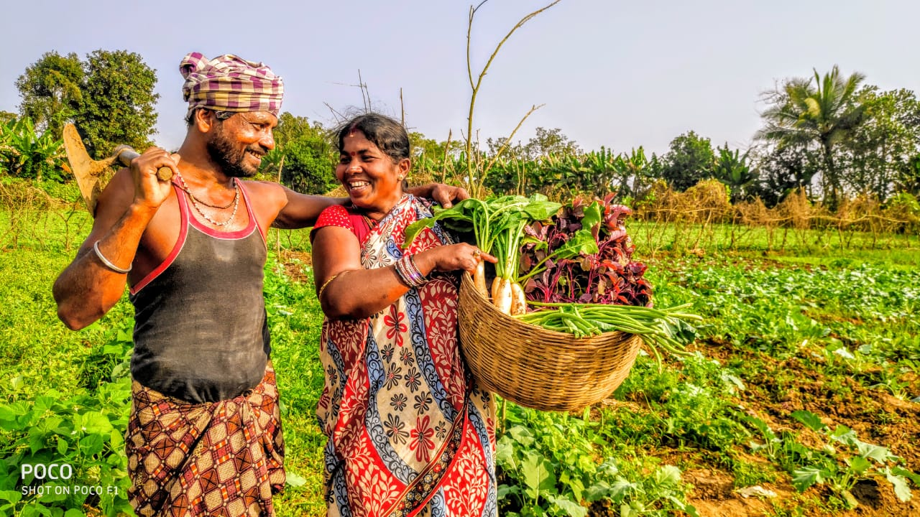

---------------*-------------------------*----------------

**BAIF Institute for Sustainable Livelihood & Development**

1. **BAIF Institute for Sustainable Livelihood & Development**

The illustration below shows the activity structure of the BAIF Kitchen Garden approach.

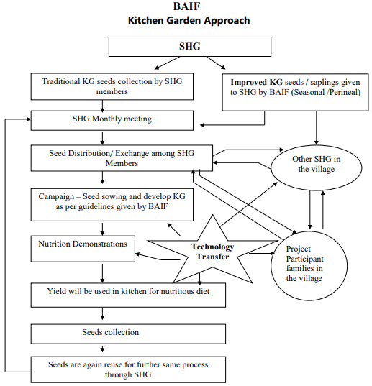

---------------*-------------------------*----------------

**Support to the TARINA Families**

A three-time support was given to TARINA families to ensure the availability of nutrition in seasonal deficit days during the year.

* The seed for Kitchen gardens in TARINA project were supported through convergence with NHRDF (National Horticulture Research & Development Foundation).
* The first year 1,202 households (against target of 1000 HH) were supported in first quarter of Dec’2016 to Nov’2017. Training support was provided by Care India the other implementing partner of TARINA project. There are 3 implementing partners across India into the project. GDS (Grameen Development Services) in U.P, CARE India in Odisha, and BAIF in Bihar.
* In year Dec’2017 to Nov 2018 another 2000 new households were supported through kitchen garden and the households supported in previous year were retained.
* In year Dec’2018 to Nov’2019, 1000 new households were added along with retaining the previous year 3000 households. The total 4000 households support was extended.

**Convergence in the BAIF TARINIA Project**

* Training in Krishi Vigyan Kendra (KVK) is done on regular basis on various aspects as kitchen garden is one of them. There is good tie-up with KVK Munger with BAIF in Munger district.
* On 17th September 2020 BAIF was invited to send participants in “Poshan Maah” events organized in KVK, Munger. Around 22 participant farmers participated in the training. (Distribution of seeds like Spinach, Fenugreek, Radish, Carrot, and coriander was done among women farmers)
* On 19th September 50 women farmers were given kitchen garden kit in Goraiya village with support of KVK, Munger.
* Convergence with OXFAM was also done post project period for 1,000 families.
* OXFAM and an NGO in Bhagalpur was converged for supporting project families for kitchen garden after completion of project. The OXFAM provided the Kitchen garden seed at subsidized rates. The MRP of the kit was Rs.230 and it was subsidized to Rs.55 for the farmers. Here around 1,000 farmers were covered through this convergence.

**UMED-MSRLM (Maharashtra State Rural Livelihood Mission)**

**C. UMED-MSRLM (Maharashtra State Rural Livelihood Mission)**

UMED nutri-gardens is small kitchen garden spreads across 1 guntha of land in the vicinity of the house, individual farm land or in common space belonging to the community. UMED Nutri-gardens is essential to meet daily nutritional needs of the members of households for better health of its member. It is circular in shape and consists of 14 raised/sunken soil beds (the type of soil bed to be developed, depends on the topography of the region and the volume of rainfall it receives) and 7 pathways. Objective of having 7 pathways in nutri garden is to be able to have access to variety of fresh and residue free vegetable throughout the 7 days of the week. The central pit in the nutri garden can be utilized either as compost pit or as Azolla pit, production in which serves good fodder for milking animals. An immediate circular shaped raised/sunken soil bed serves place for plantation of herbs and medicinal plants. Rest 14 soil beds are for the production of vegetables as per the need and preference of the family, however there should be fine balance between leafy vegetables and fruity vegetables. The circular shaped nutri garden serves better nutritional security if plants such as papaya, moringa, lemon, banana etc. are planted around the nutri garden. Climbing vegetables plants can be planted along the pathways in nutri garden. UMED’s nutri-garden is a model layout that can be replicated by an individual household to meet their daily nutritional requirements or the model could be establish by the community as their collective efforts in case there is no space for individual nutri-gardens.

**Plan and measurement of a circular bed nutri-garden**

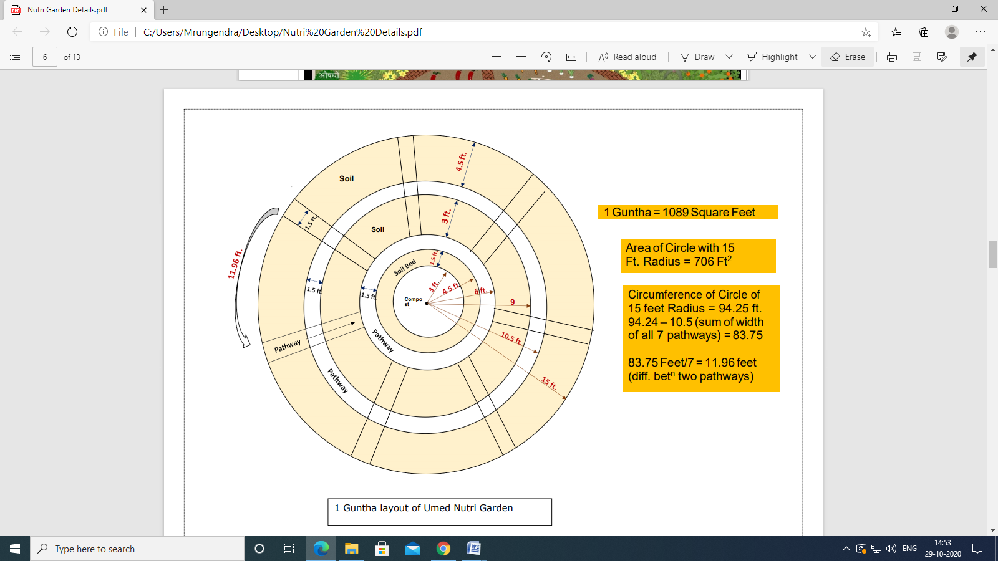

---------------*-------------------------*----------------

**UNICEF Bihar Field Office**

**D. Madhya Pradesh Mahila Vitta Evan Vikas Nigam (MVVN)**

**Preparation of Kodo/ Kutki bar**

Millets can be tough as they can survive drought, need less than 90 days from sowing to harvest & grow on poor soils. Federations had access to 30,000 Kg of Kodo millets in the first year. An appropriate nutritious recipe was developed for the bars under the supervision of ICDS with right nutritional balance including 33.4% Kodo/Kutki Millet, 16.7 Soybean, 11.6% Ghee, 25% Jaggery, 5% Peanuts and 8.3% sesame. The federations procure most of the inputs such as soybean, jaggery, peanuts and sesame locally, providing markets to local producers. Once the recipes were finalized, several rounds of trial runs were done to ensure, taste and quality met the requirements of the ICDS department. Quality and Nutritional content testing was done at NABL certified labs in Hyderabad with support from Tejaswini project.

**E. Welthungerhilfe**

**Participatory Learning & Action – Linking Agriculture & Natural Resources with Nutrition (PLA-LANN)**

Linking Agriculture, Natural Resources and Nutrition (PLA-LANN) is a nutrition-sensitive approach for management and planning of agriculture and natural resources by the community in a way that helps them achieve sustainable food and nutrition security. This ‘planning and management’ requires sensitization, knowledge and skills regarding nutrition, child care, agriculture, water and other resource management, WASH and entitlements. Under Welthungerhilfe’s Fight Hunger First Initiative, the sensitization and knowledge enhancement of the community on LANN is done using a participatory methodology called PLA – Participatory Learning for Action. The PLA is done through subsequent meetings in the community. Our PLA manual on LANN uses 17 meeting cycles in 4 phases:

* Assessment – Taking stock of the problems and understand its immediate and underlying causes
* Decision – Arriving at a consensual decision for doable actions on improving the nutrition status
* Action – Drawing an action plan with duly allocated roles and responsibilities
* Evaluation – Social Auditing by the participants of outcomes and impact of the Linking Agriculture to Natural Resource Management & Nutrition (LANN) process

The perceptible outcomes of the LANN PLA process are:

* Increased savings and improved health
* Reduced migration of men to other states in hunger periods
* Increased food availability for the whole family throughout the year
* Complete freedom from moneylenders
* Malnutrition reduced considerably

For more details: - https://welthungerhilfeindia.org/linking-agriculture-to-nrm-nutrition-for-behaviour-change/#:~:text=The%20LANN%20%E2%80%93%20PLA%20process%20takes,achieve%20food%20and%20nutrition%20security.

|  |  |
| --- | --- |
| **APAARI**  **GLOSSARY** | Asia-Pacific Association of Agricultural Research Institutions |
| **APPI**  **BLRP** | Azim Premji Philanthropic Initiatives  Block Level Resource Person |
| **CFNS** | Coalition for Food and Nutrition Security |
| **CGIAR** | Consortium of International Agricultural Research Centers |
| **CNG** | Community Nutrition Garden |
| **CORD** | Chinmaya Organization of Rural Development |
| **CRP** | Community Resource Person |
| **CTARA** | Centre for Technology Alternatives for Rural Areas |
| **FAO** | The Food and Agriculture Organization of the United Nations |
| **GDS** | Grameen Development Services |
| **GoI** | Government of India |
| **GoO** | Government of Odisha |
| **HZL** | Hindustan Zinc Limited |
| **ICARDA** | International Center for Agricultural Research in the Dry Areas |
| **ICMR** | Indian Council of Medical Research |
| **IFAD** | International Fund for Agricultural Development |
| **JNKVV** | Jawaharlal Nehru Krishi Vishwa Vidyalaya |
| **KG** | Kitchen Garden |
| **KVK** | Krishi Vigyan Kendra |
| **MDD** | Minimum Dietary Diversity |
| **MGNREGA** | Mahatma Gandhi National Rural Employment Guarantee Act |
| **MoRD** | Ministry of Rural Development |
| **MSRLM** | Maharashtra State Rural Livelihood Mission |
| **MSSRF** | M S Swaminathan Research Foundation |
| **MUB** | Mo Upakari Bagicha |
| **MVVN** | Madhya Pradesh Mahila Vitta Evan Vikas Nigam |
| **NHRDF** | National Horticulture Research & Development Foundation |
| **NIN** | National Institute of Nutrition |
| **NRLM** | National Rural Livelihood Mission |
| **OLM** | Odisha Livelihood Mission |
| **ONAP** | Odisha Nutrition Action Plan |
| **PLA LANN** | Participatory Learning and Action, Linking Agriculture & Natural Resources with Nutrition |
| **SRLM** | State Rural Livelihood Mission |
| **UNICEF** | United Nations Children’s Fund |
| **WHH** | Welthungerhilfe |
|  |  |
|  |  |
|  |  |
|  |  |
|  |  |

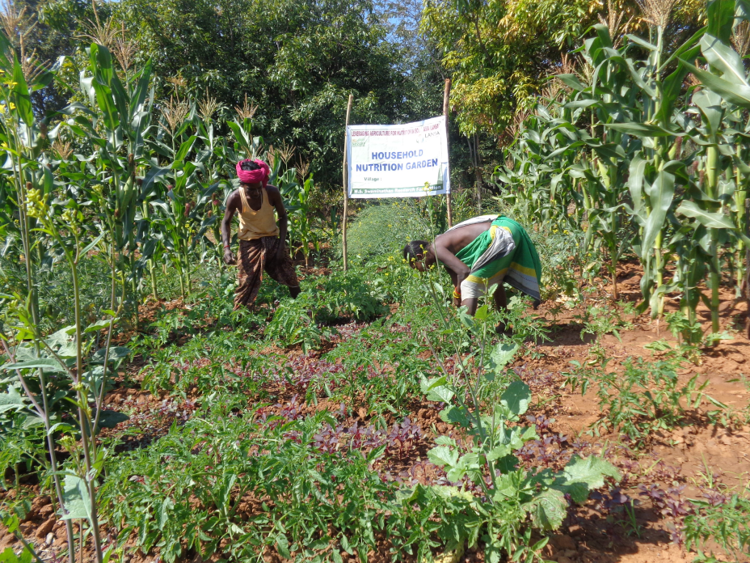

Picture Credits: MSSRF

Picture Credits: MSSRF

**PUBLISHED BY**



**THE COALITION FOR FOOD & NUTRITION SECURITY (CFNS)**

B-40, NRPC COLONY, BLOCK- B

QUTAB INSTITUTIONAL AREA, NEW DELHI

PIN CODE- 110016

011-41058548

1. https://in.one.un.org/page/sustainable-development-goals/sdg-2/, last accessed 13/11/2020
2. Black, R. E., Allen, L. H., Caulfeild, L. E., De Onis, M., Ezzati , M., Mathers , C., & Rivera , J. (2008). Maternal and Child Undernutrition Study Group. Maternal and child undernutrition: global and regional exposures and health consequences. Lancet , 371:243–60
3. Lopez, A. D., Mathers, C. D., Ezzati, M., Jamison, D. T., & Murray, C. J. (2006). Global and regional burden of disease and risk factors, 2001: Systematic analysis of population health data. *Lancet*, 367:1747–57
4. IFPRI. (2017). *National policies and strategic plans tackle undernutrition india - review.* IFPRI
5. Gragnolati, M., Bredenkamp, C., Shekar, M., Gupta, M. D., & Lee, Y. K. (2006). *India's Undernourished Children.* The World Bank
6. Aggarwal A, Verma S, Faridi MMA, Dayachand. Complementary feeding reasons for inappropriateness in timing, quantity and consistency. Indian J Pediatr. 2008; 75:49-53
7. WHO (2006) Adolescent Nutrition: A Review of the Situation in Selected South-East Asian Countries. SEA-NUT-163. Regional Office for South East Asia, New Delhi
8. WHO/FAO (1996) Preparation and Use of Food-Based Dietary Guidelines. WHO/NUT/96.6. Nutrition Programme, World Health Organization, Geneva
9. Ruel, M. T. (2003) Operationalizing dietary diversity: a review of measurement issues and research priorities. *Journal of Nutrition* 133, 3911S–3925S
10. Underwood, B. A. (1998) From research to global reality: the micronutrient story. Journal of Nutrition 128, 145–151
11. Menon, P., A. Bamezai, A. Subandoro, M. A. Ayoya, and V. Aguayo (2015). Age-Appropriate Infant and Young Child Feeding Practices are Associated with Child Nutrition in India: Insights from Nationally Representative Data. *Maternal and Child Nutrition* 11, 73–87
12. Agrawal, S., Kim, R., Gausman, J., Sharma, S., Sankar, R., Joe, W., & Subramanian, S. V. (2019). Socio-economic patterning of food consumption and dietary diversity among Indian children: evidence from NFHS-4. *European journal of clinical nutrition*, 1
13. https://www.nrega.nic.in/netnrega/WriteReaddata/Circulars/2417Nutri_garden.pdf
14. WCD Secretary letter to All chief Secretaries, dated – 28th august 2020
15. http://www.nutritioncoalition.org.in/webinar-nutri-garden/